30/10/2026
Raised request for access to [unix.ncl.ac.uk] via the website [https://nuservice.ncl.ac.uk/HEAT/Modules/SelfService/#serviceCatalog]

31/10/2026
Previously raised request did not work
Raised request for access to unix.ncl.ac.uk via a form available on the website [https://services.ncl.ac.uk/itservice/technical-services/unix-time-sharing/] - needs 24h to activate

01/11/2026
Access to [unix.ncl.ac.uk] obtained
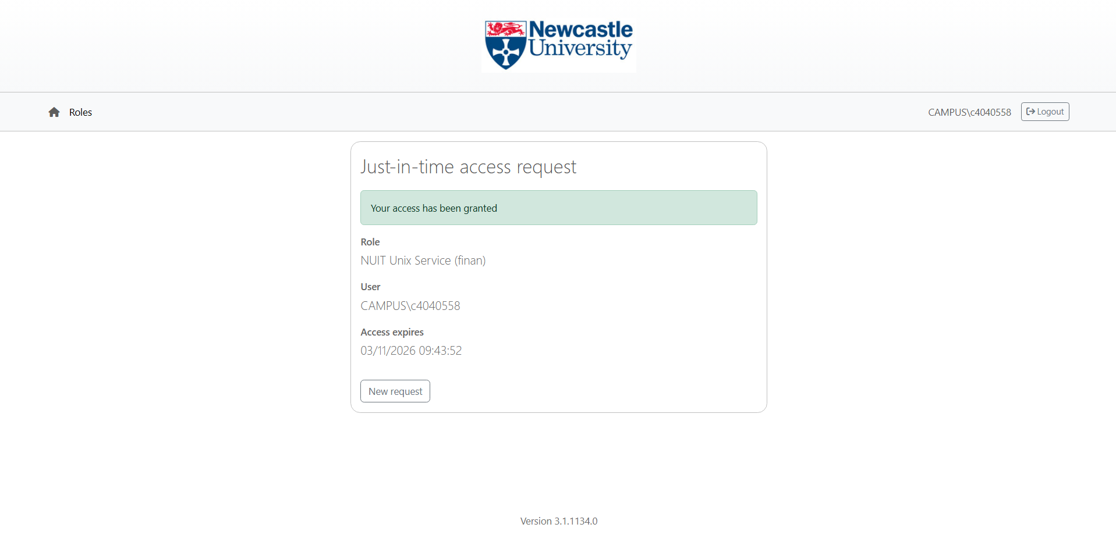
Tried connecting to MasterPi via ssh from command prompt
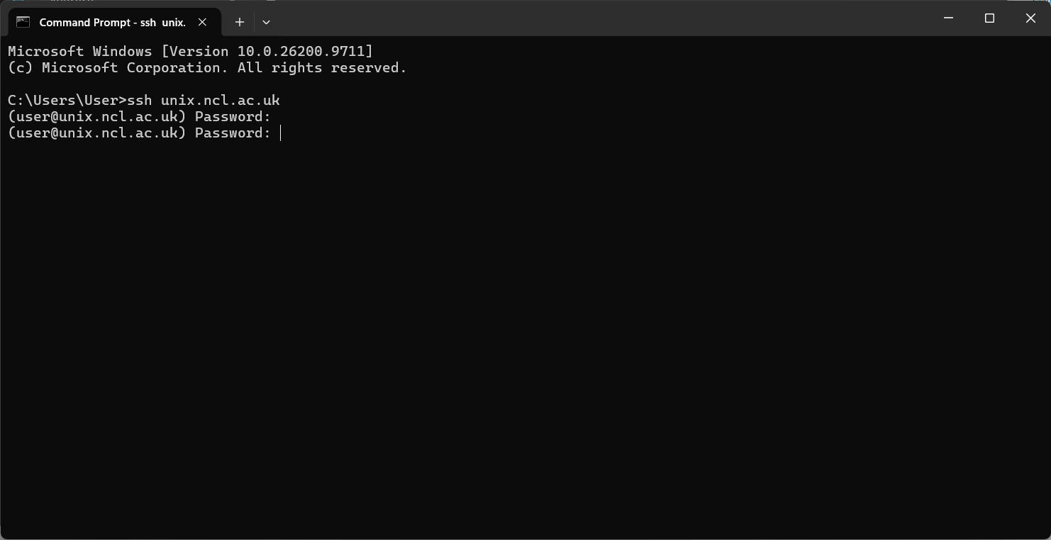
Failed to connect with [unix.ncl.ac.uk] – I needed to append username [login@unix.ncl.ac.uk]
Connected to [unix.ncl.ac.uk] server by using the right ssh id and university login password
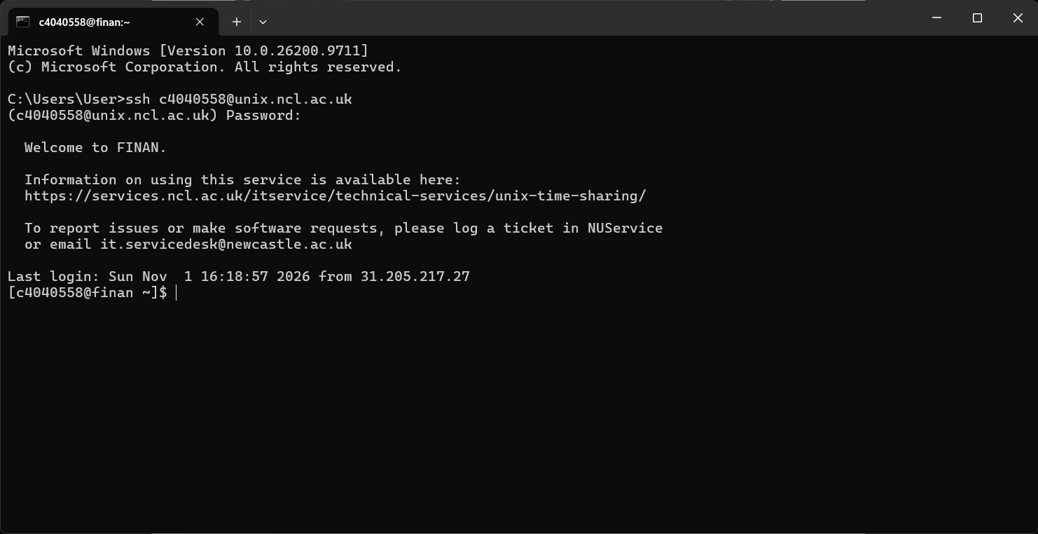
Tried connecting to ManagerPi3 [Group 3] via ssh
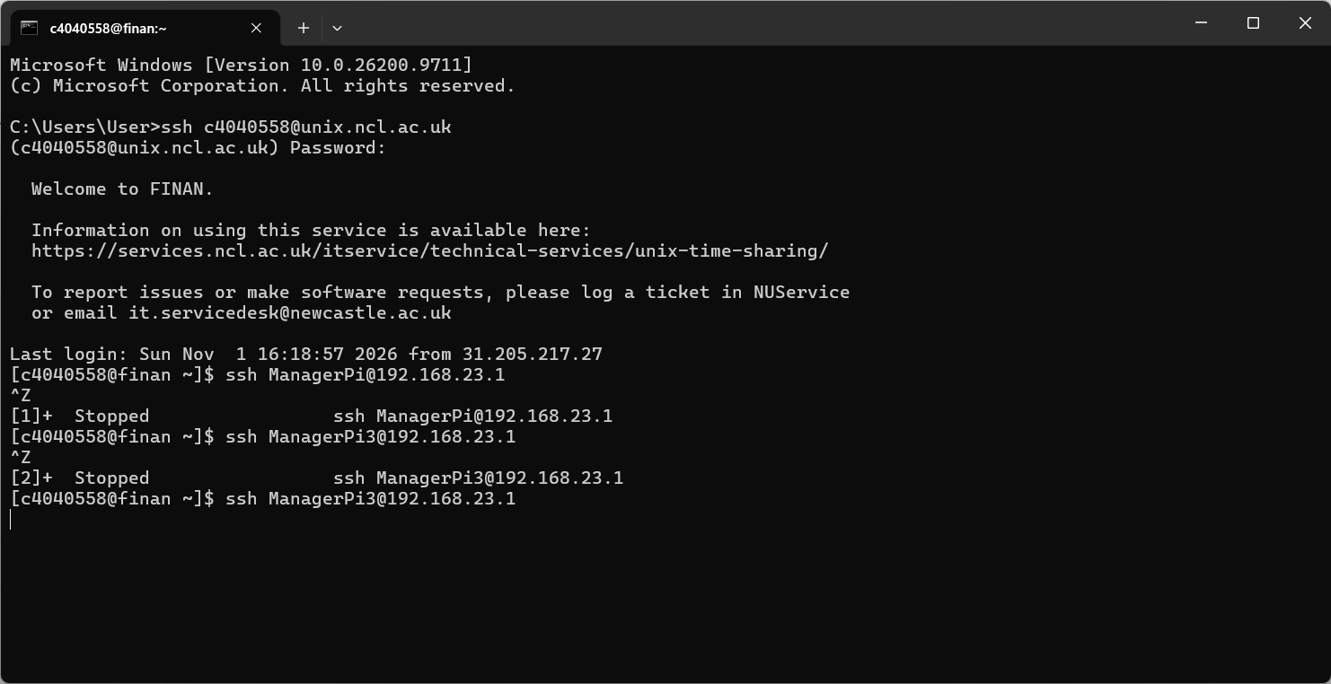
Failed – presumably because ssh keys were not generated and authenticated

02/11/2026
Downloaded PuTTY from Microsoft Store [https://apps.microsoft.com/detail/XPFNZKSKLBP7RJ?hl=en-US&gl=GB&ocid=pdpshare]
Connected to [unix.ncl.ac.uk] using PuTTY
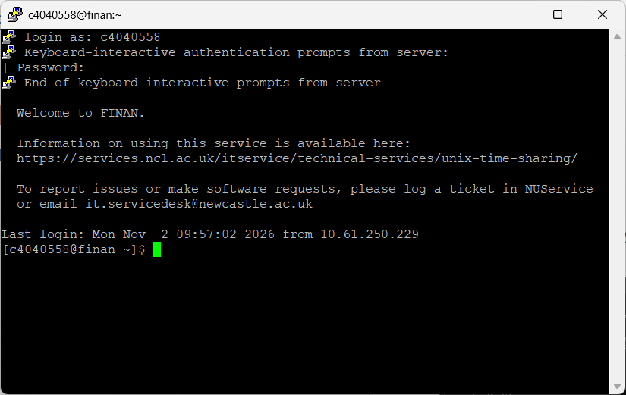
Generated ssh keys as per [Lecture 3 M2M with SSH-1.pdf - https://ncl.instructure.com/courses/70671/files/11087442?wrap=1] using [ssh-keygen]
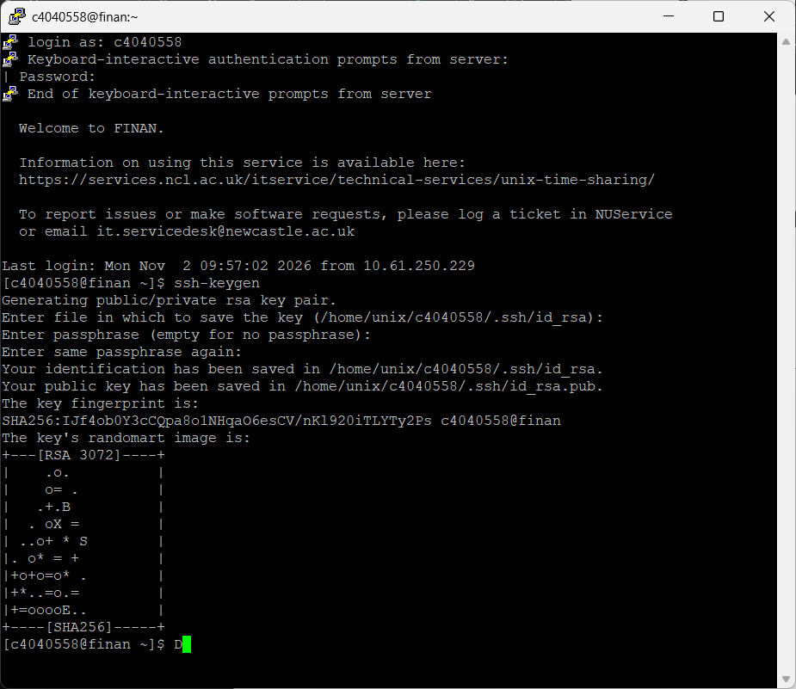
Passphrase left empty – as per instructions
Saved ID in [/home/unix/c4040558/.ssh/id_rsa]
Saved Public Key in [/home/unix/c4040558/.ssh/id_rsa.pub]
Connected to [ManagerPi3] after a few tries, following instructions as per [coursework1.pdf - https://ncl.instructure.com/courses/70671/files/11051635?wrap=1] using [ssh -Y -p 10322 c4040558@localhost]
Used ssh tunnels to try utilizing Local Port Forwarding to access video stream [ssh -L 10380:192.168.23.1:10380 c4040558@unix.ncl.ac.uk]
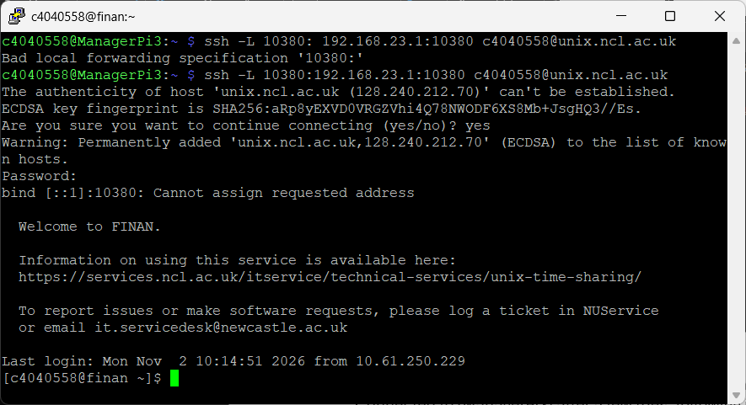
Failed with error in binding port addresses
Tried again while forcing IPv4 binding
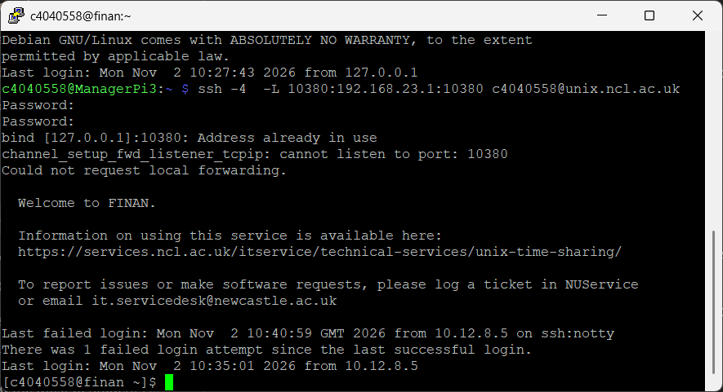
Failed with error in requesting local port forwarding – address already in use on local port
Used [netstat -ano] to find all ports in use
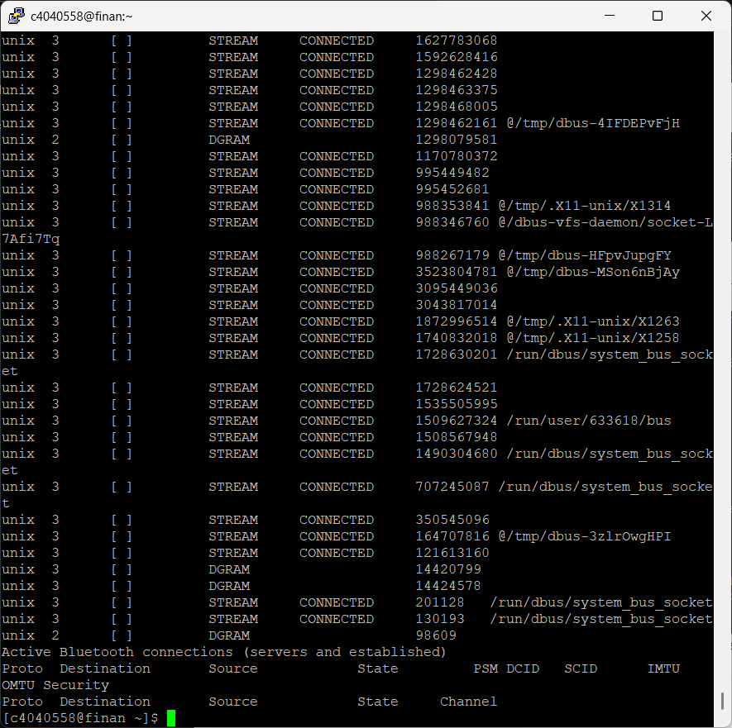
Checked for port [10380] on local machine – returned as occupied
Tried a higher address port [18080] on local machine – returned as free
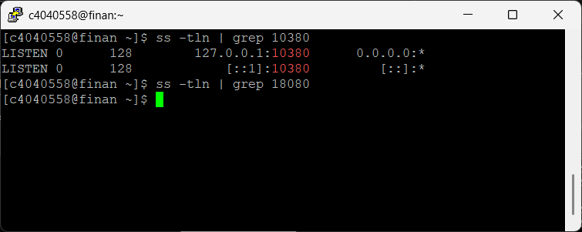
Considered using port [18080] for local port forwarding
Used ssh tunnels to try utilizing Local Port Forwarding to access video stream [ssh -L 18080:192.168.23.1:10380 c4040558@unix.ncl.ac.uk]
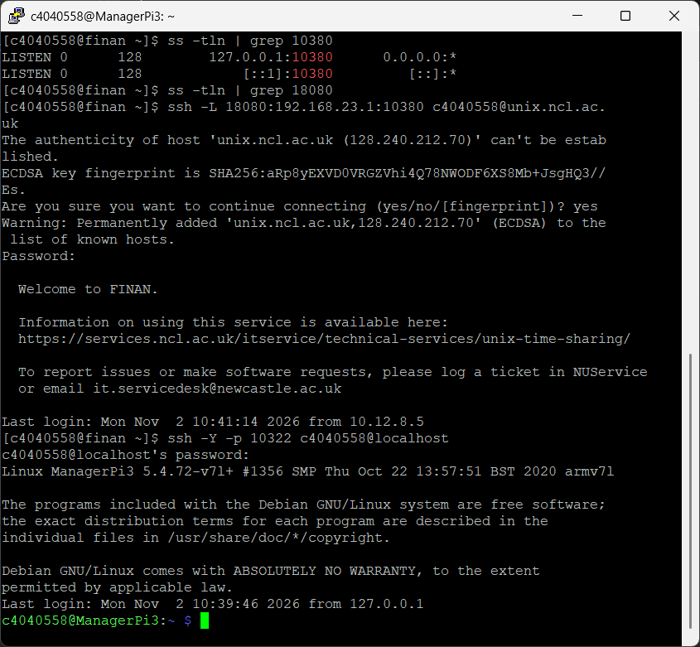
No error – got automatically logged out
Port was not successfully forwarded

Fixed error – using the wrong hostname – switched to using [localhost]
Tried using [ssh - y -p 10322 -L 10380:192.168.23.1:10380 c4040558@localhost]
Also tried using [ssh - y -p 10380 -R 28080:192.168.23.1:10380 c4040558@localhost]
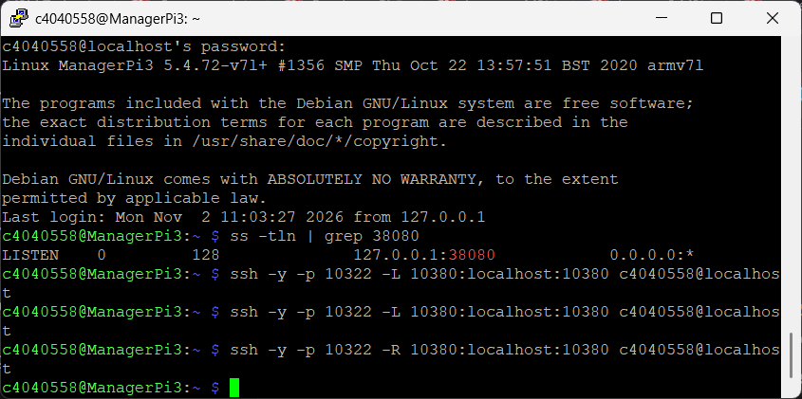

Failed both trials
Downloaded X2Go Client [https://wiki.x2go.org/doku.php/doc:installation:x2goclient]
Used [who], [ifconfig] and [route] on [ManagerPi3] to gather info
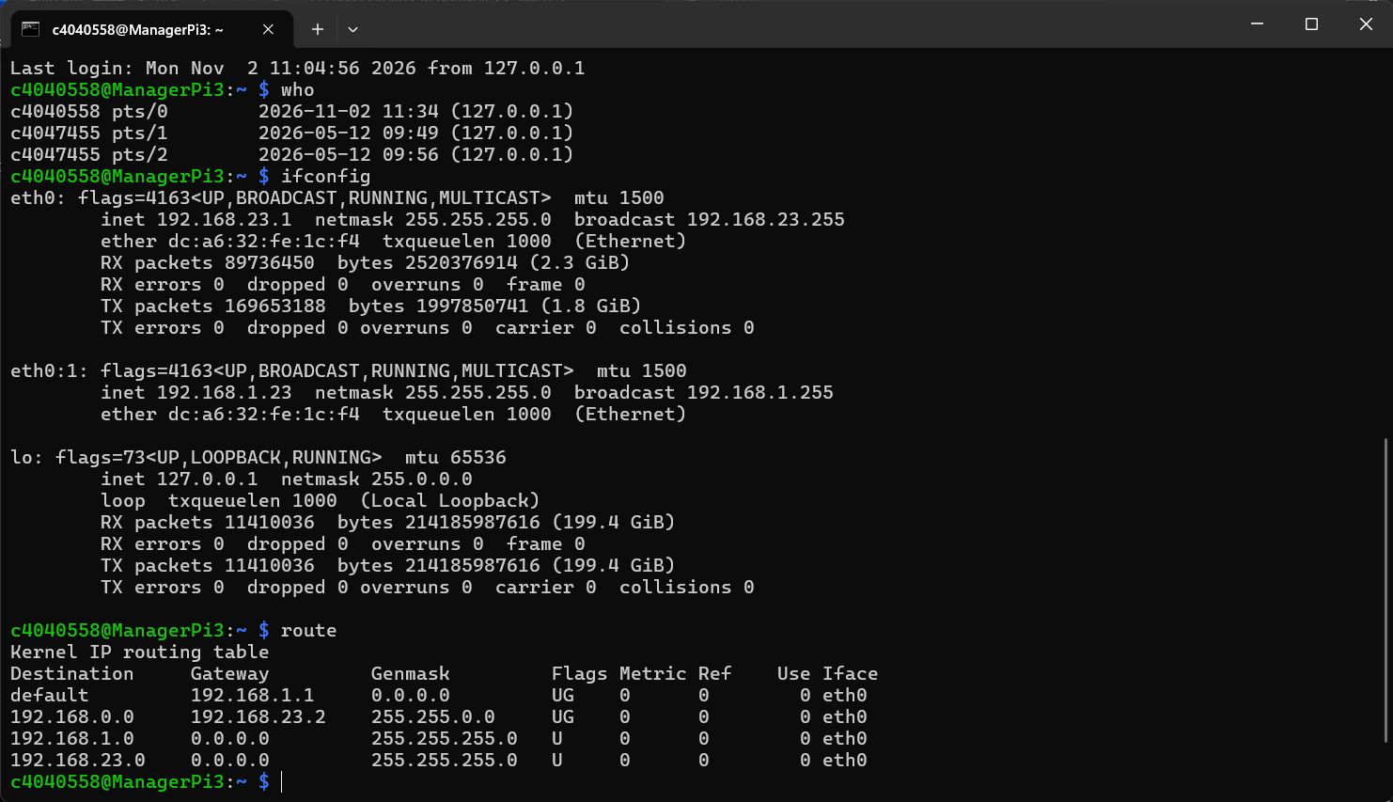
[default 0.0.0.0] – obtained by using [route -n] instead of [route]
Used [arp] and [ping localhost] on [ManagerPi3] for more info
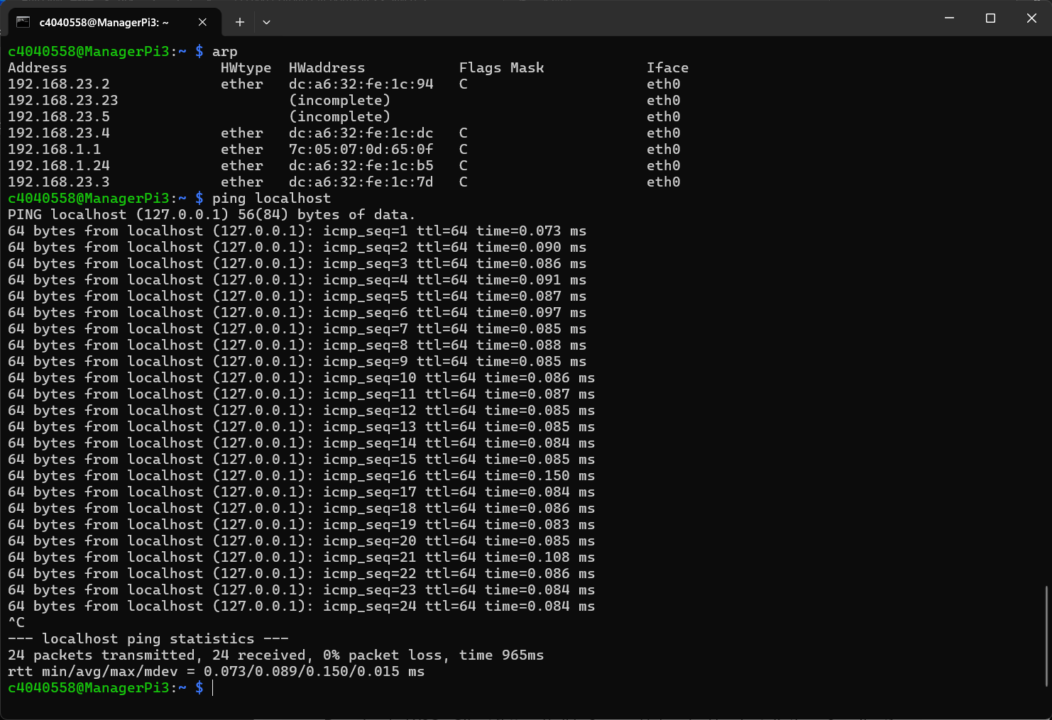
Connected to [MasterRig32x] using [ssh pi@192.168.23.2] with common password [eee.8089?] and used [who] to verify user connection
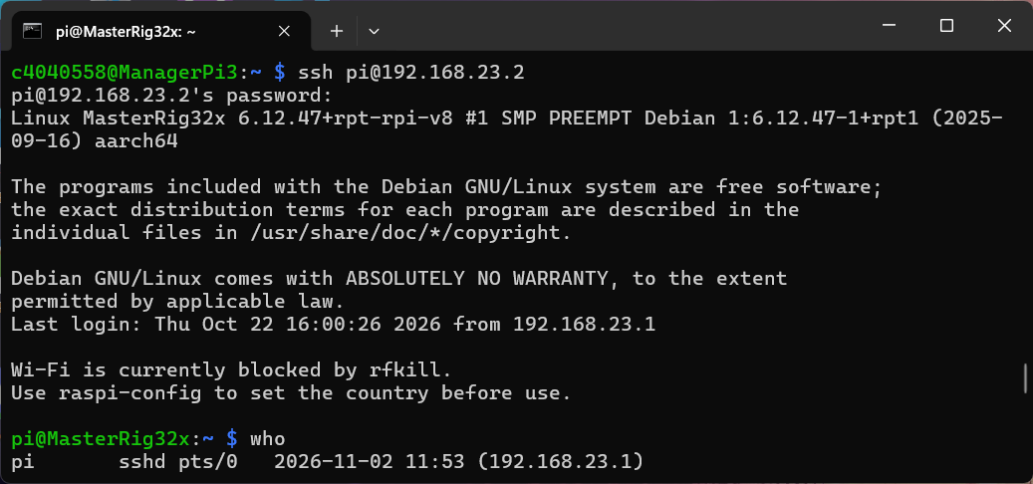
Used [ls] to list directories and [ls rootfs5/etc] to explore further
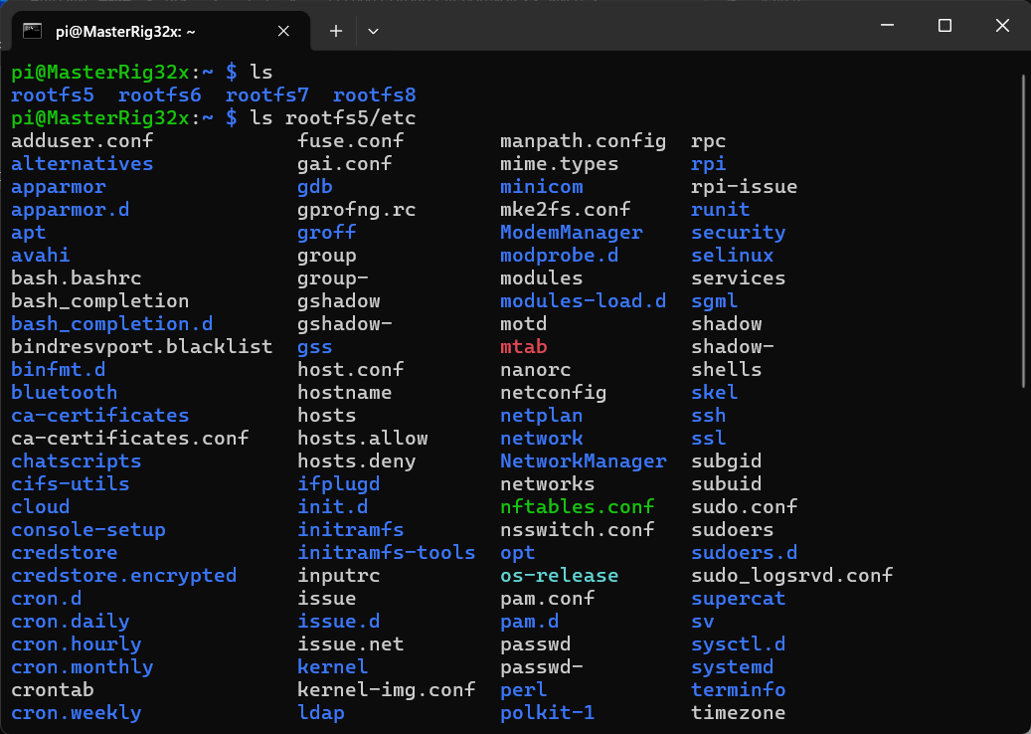
Used [ssh -L 10380:localhost:10380 c4040558@unix.ncl.ac.uk] to connect to the video stream over [localhost:10380]
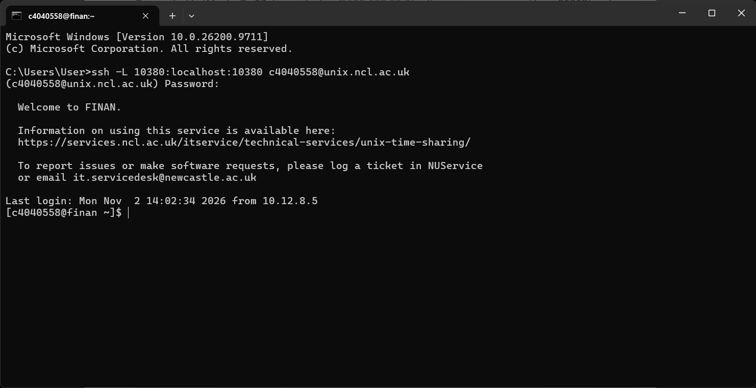
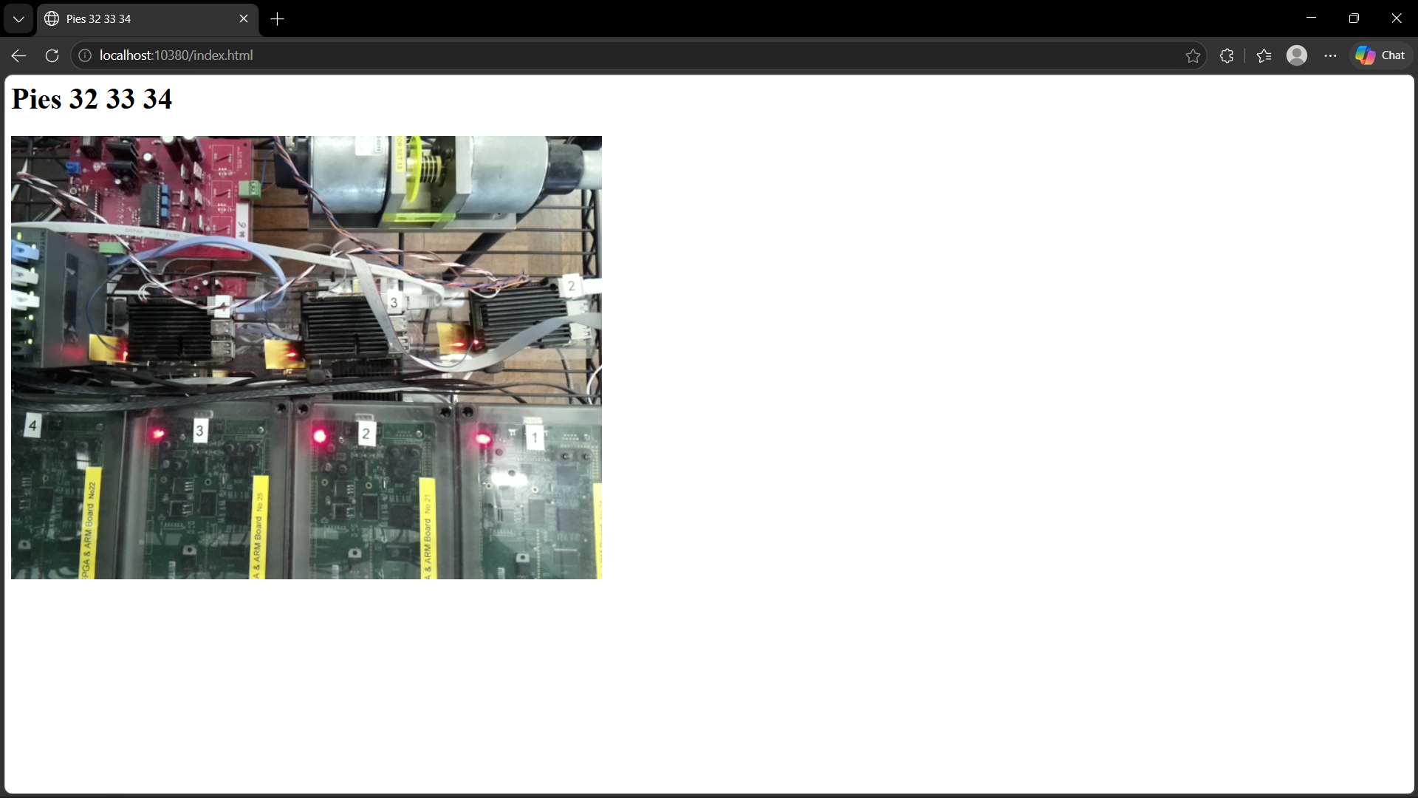
Created a boot file [boot_5] using [touch ~/boot_5] and rebooted MasterRig32x using [sudo reboot]
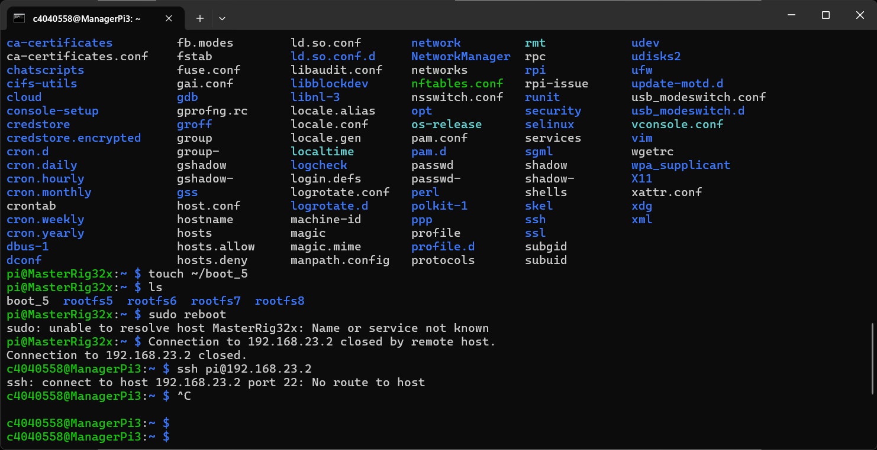
Accessed a file using [less /etc/network/interfaces] to obtain network data and copied it into the [rootfs5/etc/network/interfaces] file using [cp -a /etc/network/interfaces rootfs5/etc/network/interfaces]
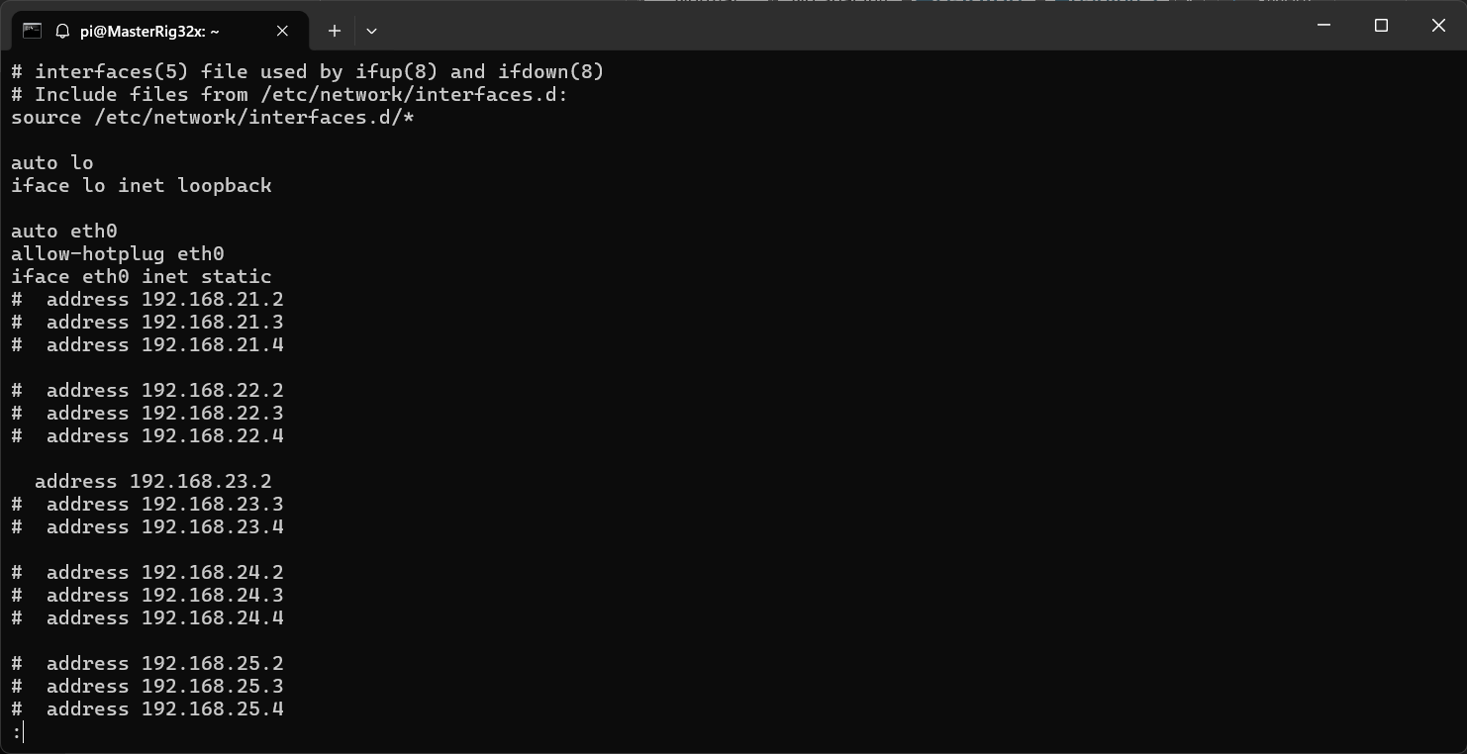
Created a file using [touch ~/boot_5] to boot the [MasterRig32x] RPi into [rootfs5] and therefore into [MyRig5]
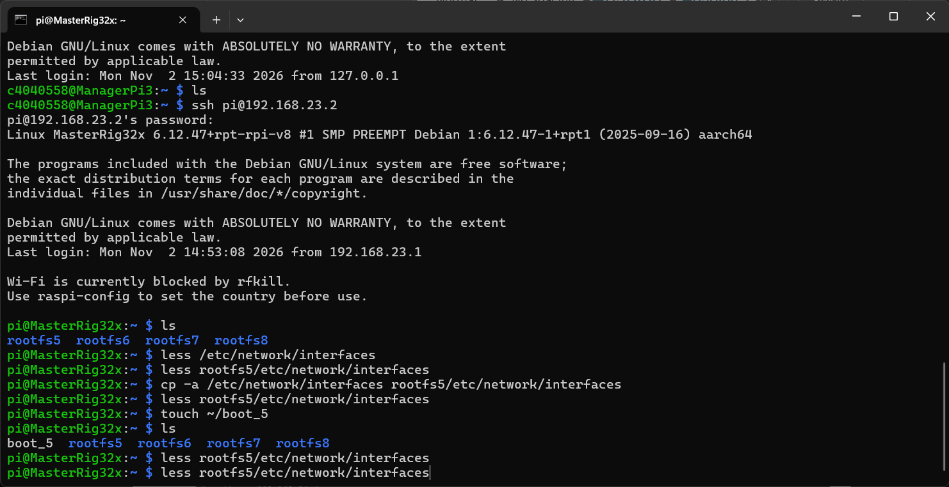
Rebooted the [MasterRig32x] RPi to load into [MyRig5]
Tried connecting using [ping 192.168.23.2] to check if [MyRig5] is awake
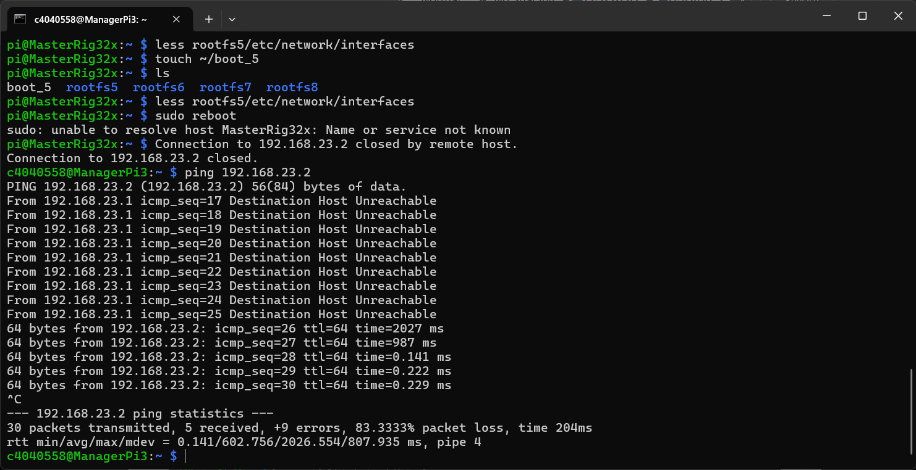
Connected to [MasterRig32x] with [MyRig5] loaded and booted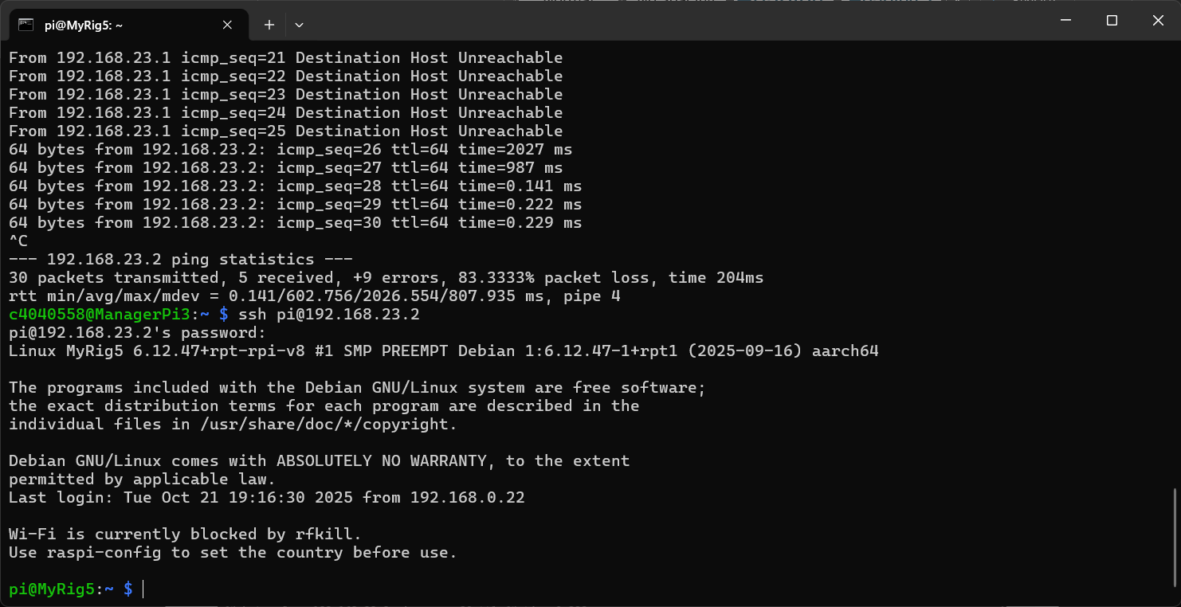
Distributed ssh keys by generating on [ManagerPi3] and copying it to [MasterRig32x], [MasterRig33x] and [MasterRig34x] – allows access without needing password upon each connection request
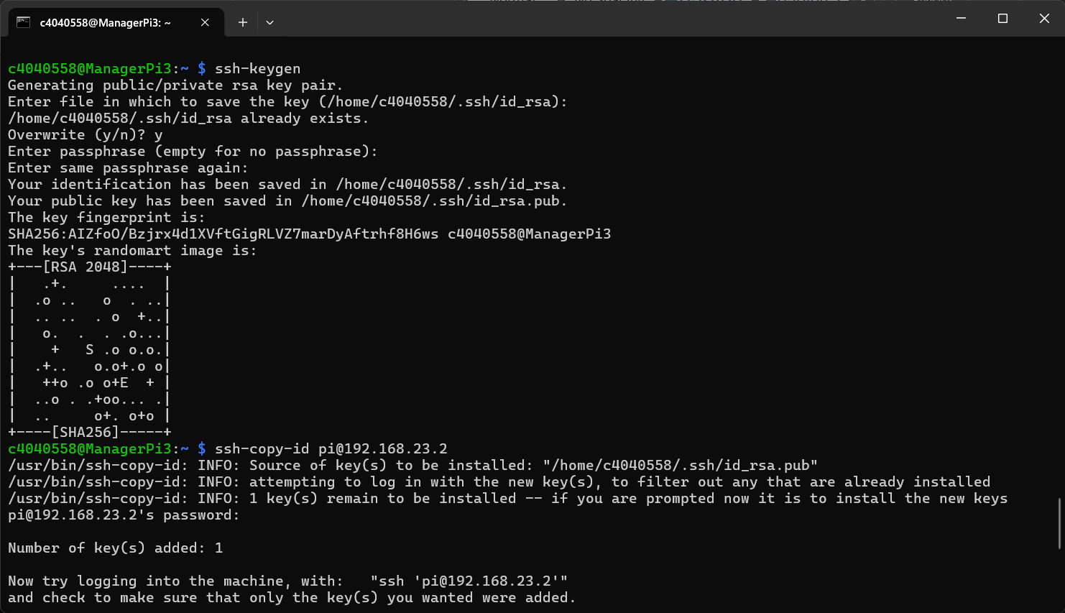
Use [nc] to set up a connection between two [MyRig] RPi devices using [nc -l -p 5000] on [MyRig5] and [nc 192.168.23.2 5000] on [MyRig6] This allows a connection between [MyRig5] and [MyRig6] and can echo the typed data between the two
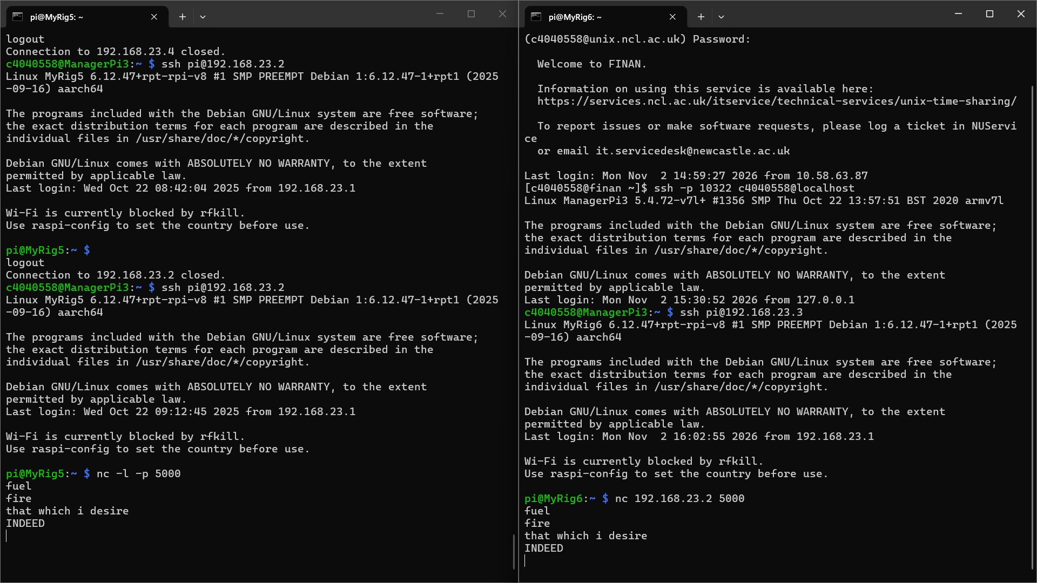
Used [echo “Hello World!” | nc 192.168.23.3] and [echo “Hello World!” | nc 192.168.23.4] to echo from [MyRig5] as the sender while using [nc -l 5000] on [MyRig6] and [MyRig7] as the receivers
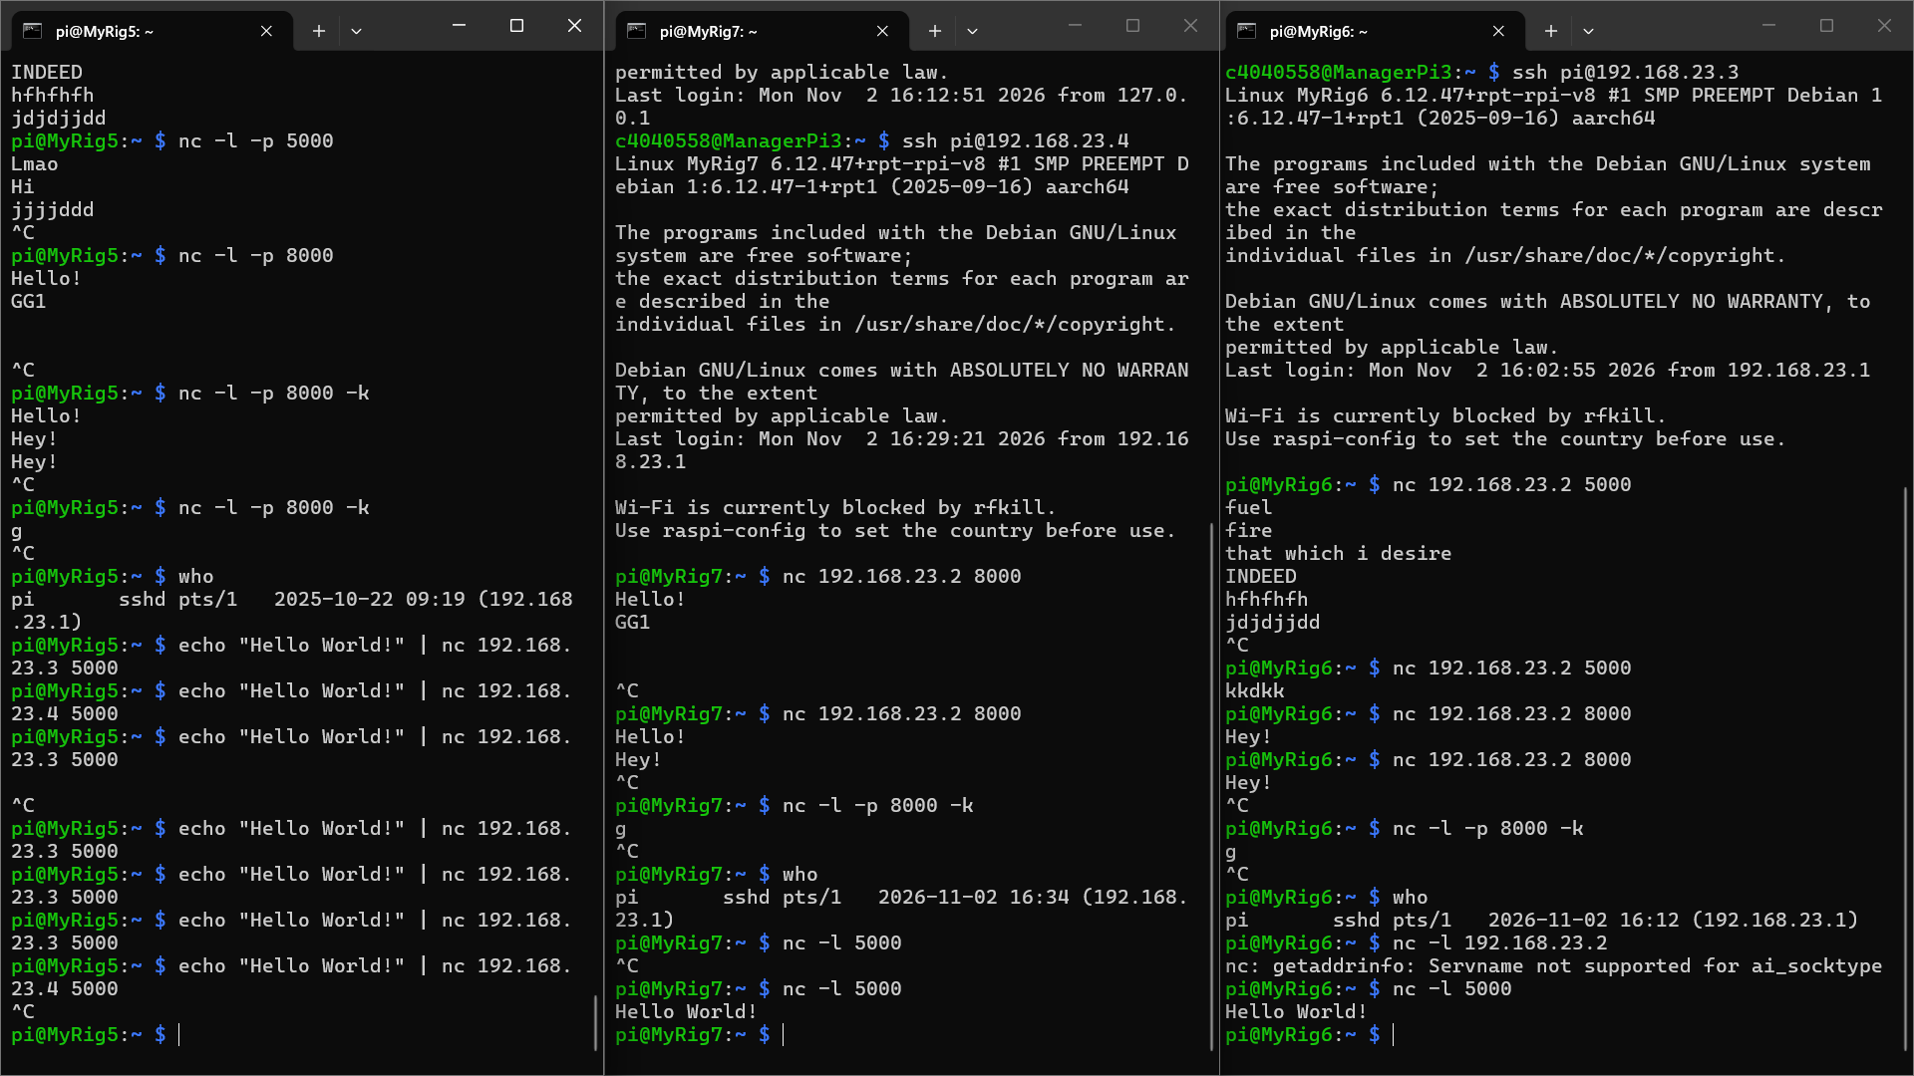

03/11/2024
Referred [Lecture 2 The Internet-1.pdf - https://ncl.instructure.com/courses/70671/files/11064576?wrap=1] for handling broadcast tables and disabling redirects
Noted down routing tables for each rig
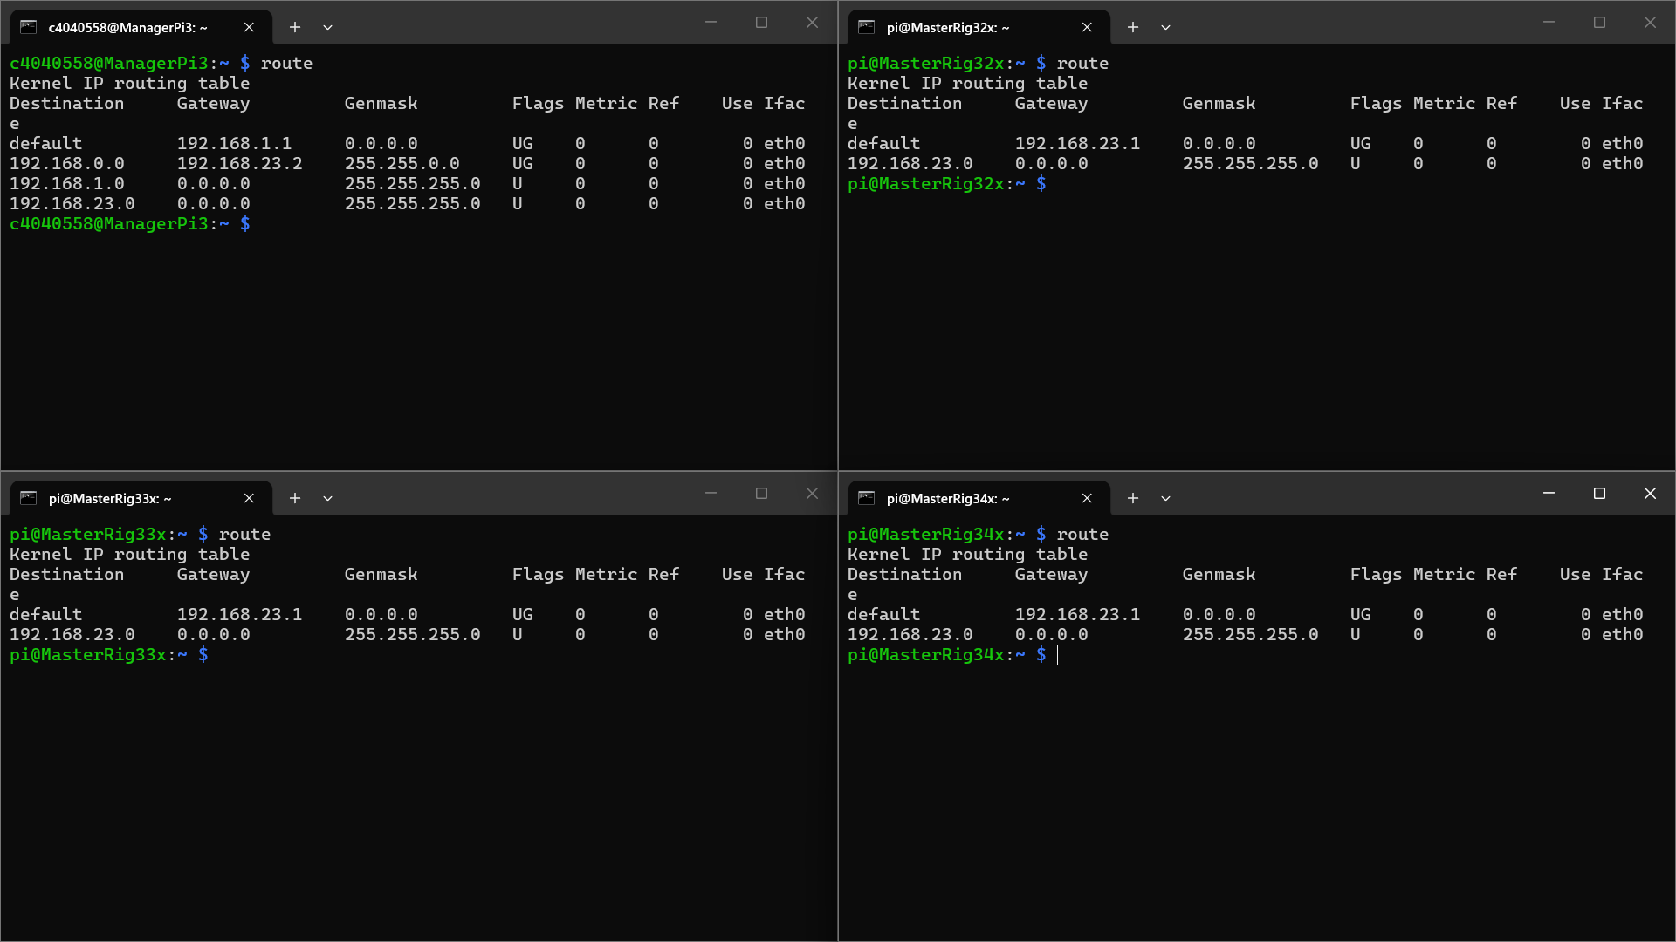
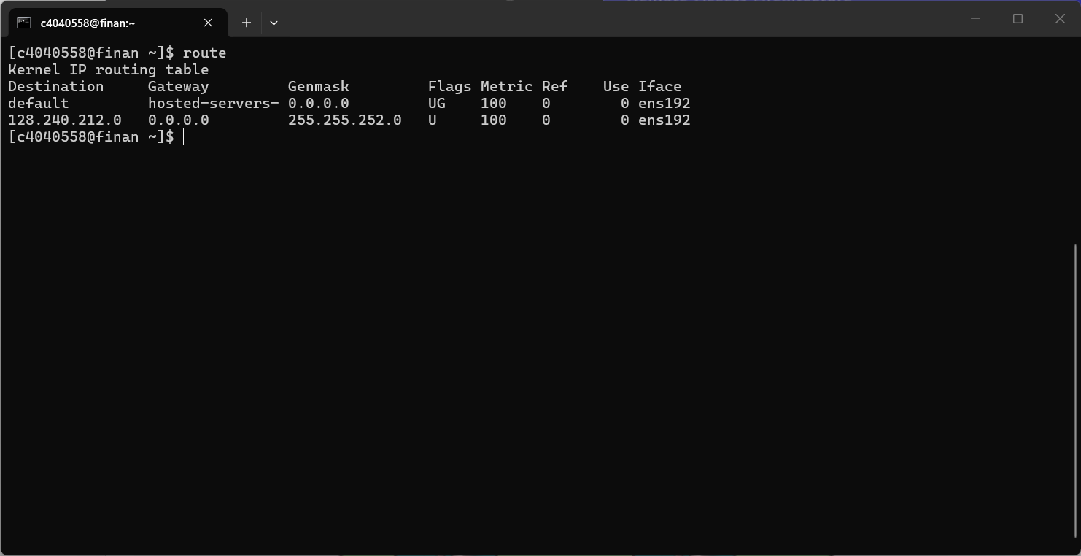
Converted to required routing in new network
<include initial table and final table>
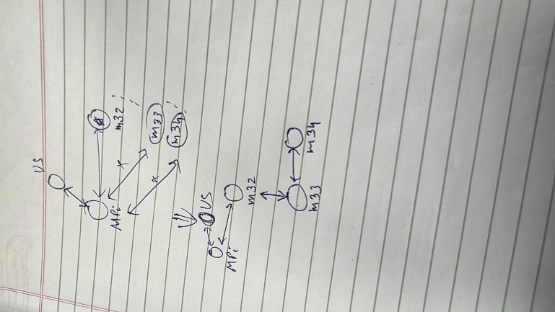
To create routing tables:
Address Refers to personal address or addresses (in case of multihoming – used by creating another eth port in configurations)
Netmask Refers to the range of applicable addresses
Gateway Refers to the address of the rig behaving as a network gateway between any two rigs
All of these are to be edited on [rootfs*/etc/network/interfaces] (* - 5/6/7)
Used ManagerPi routing table for reference
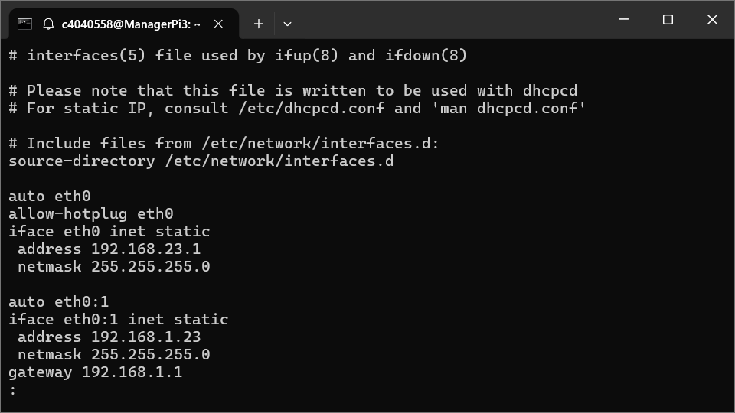
Created the following diagram based on routing requirements and IP addresses listed in [coursework1.pdf - https://ncl.instructure.com/courses/70671/files/11051635?wrap=1]
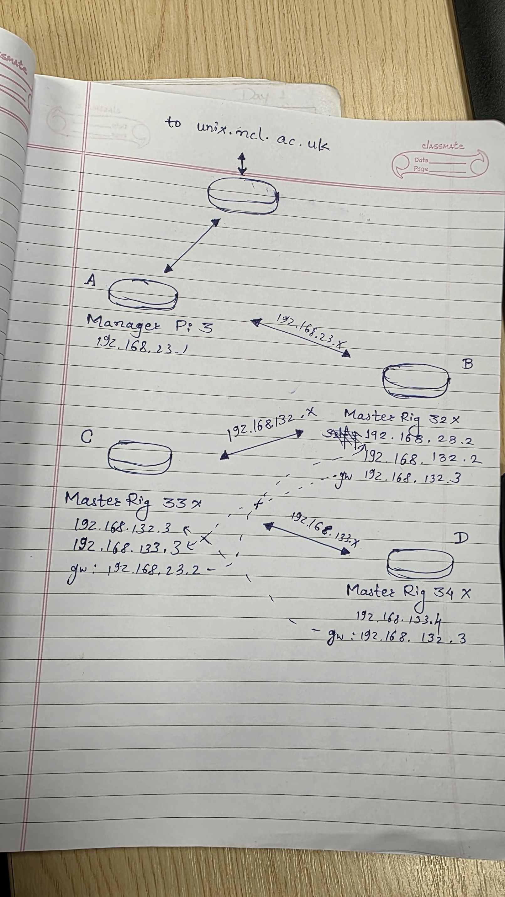
Used resources in [Lecture 2 The Internet-1.pdf - https://ncl.instructure.com/courses/70671/files/11064576?wrap=1] to build routing tables
Created the routing tables in each of the rigs
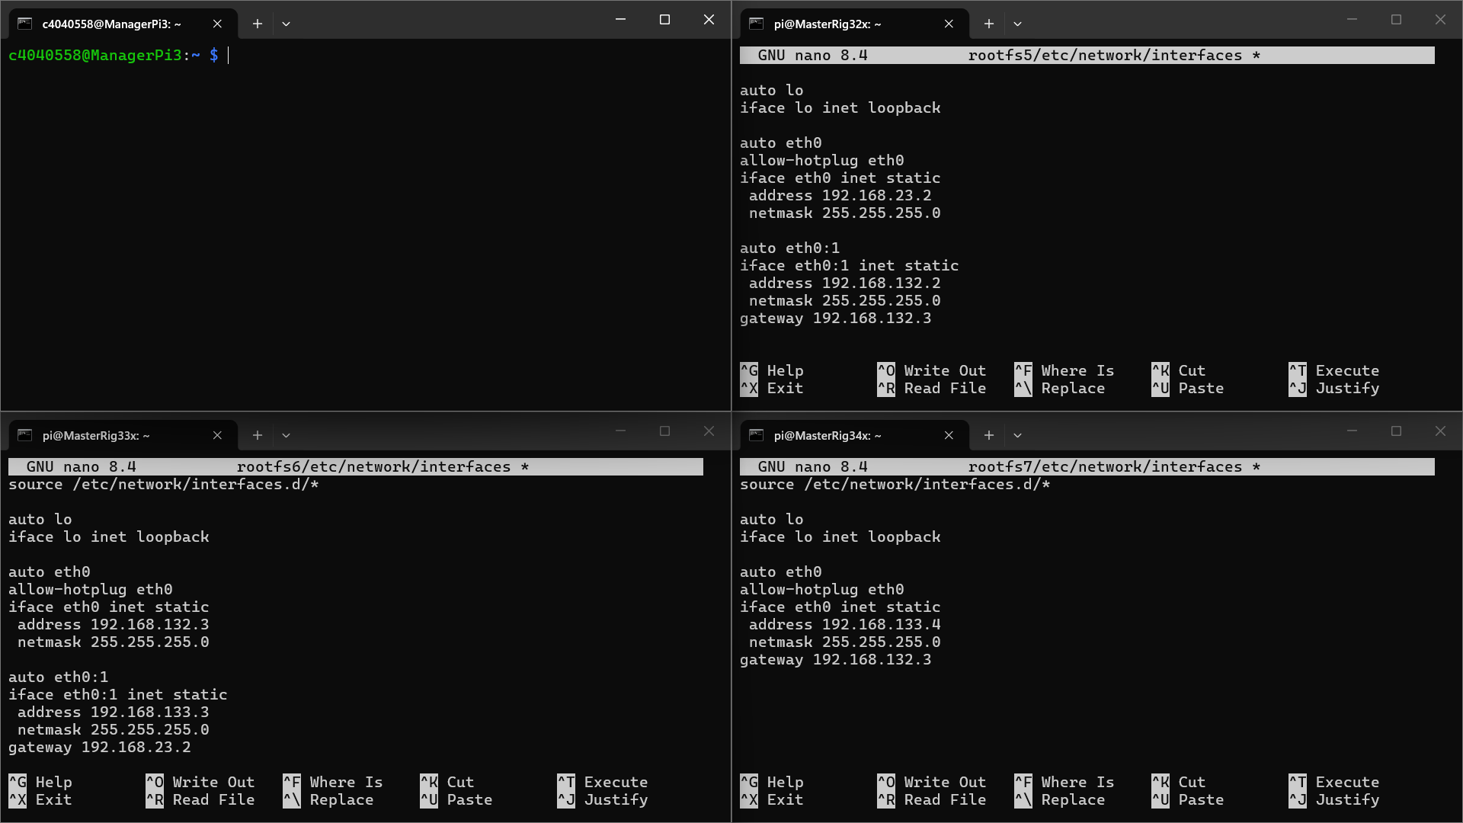
Fixed the routing tables to allow bi-directional communication
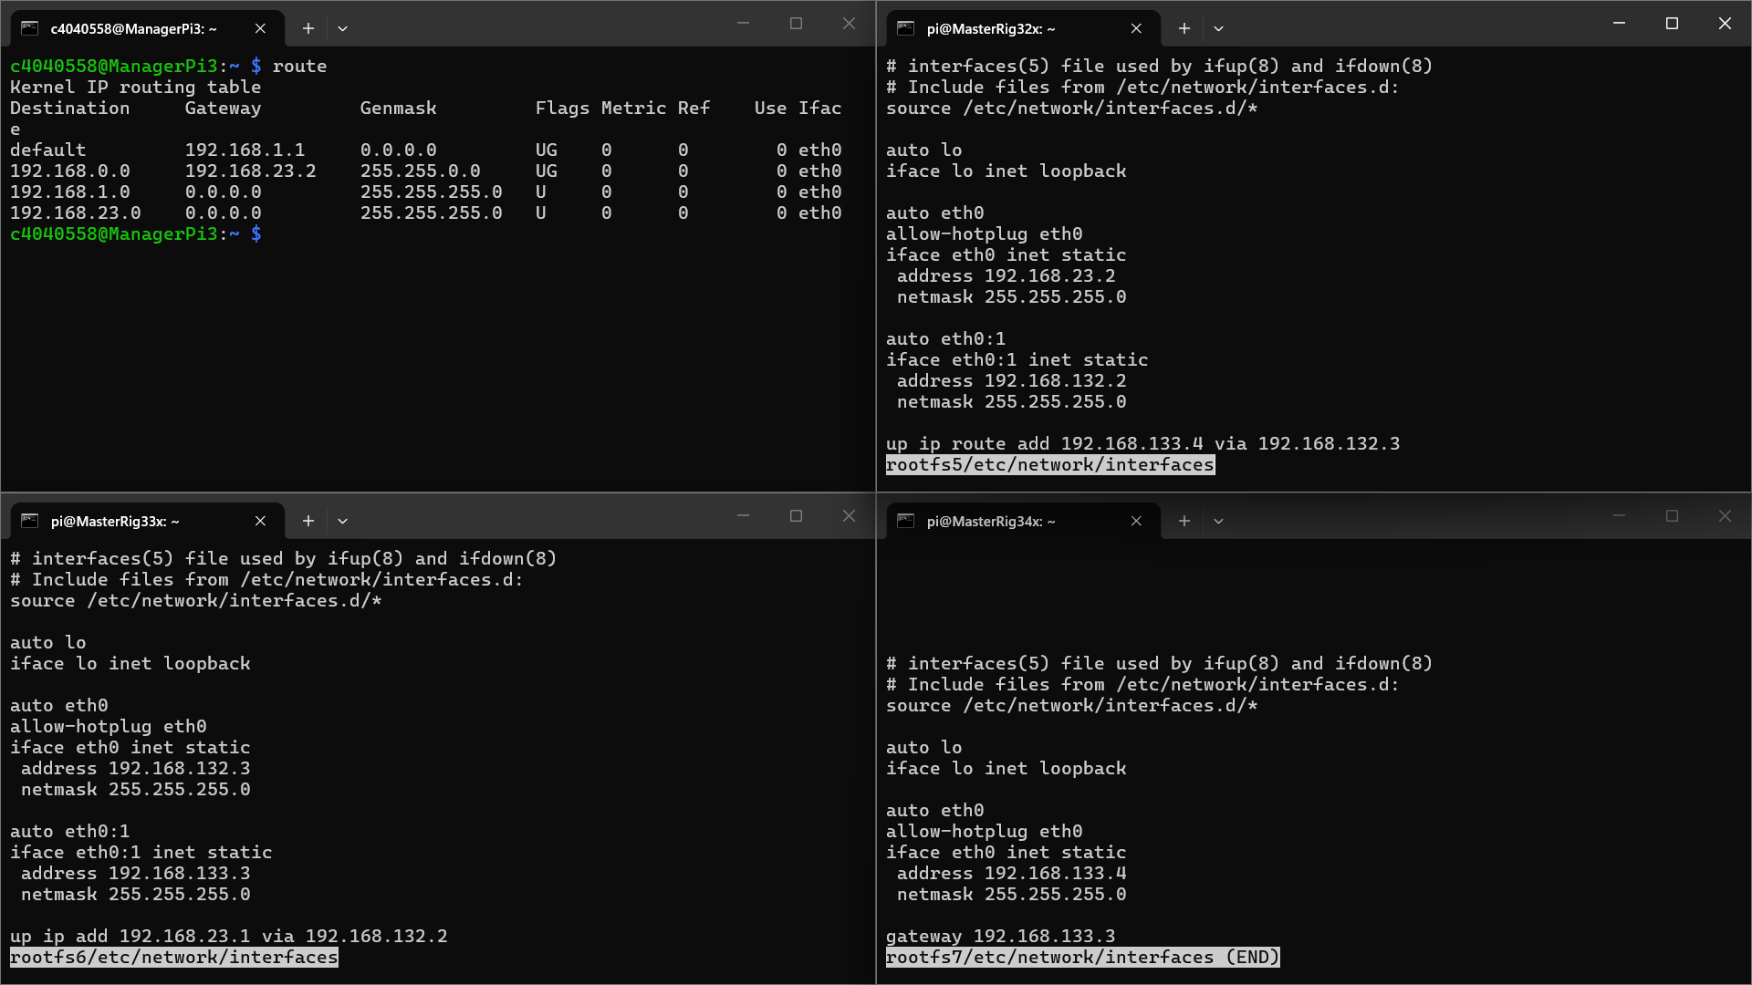
Created the config file [sysctl.conf] to enable IP Forwarding between the rigs
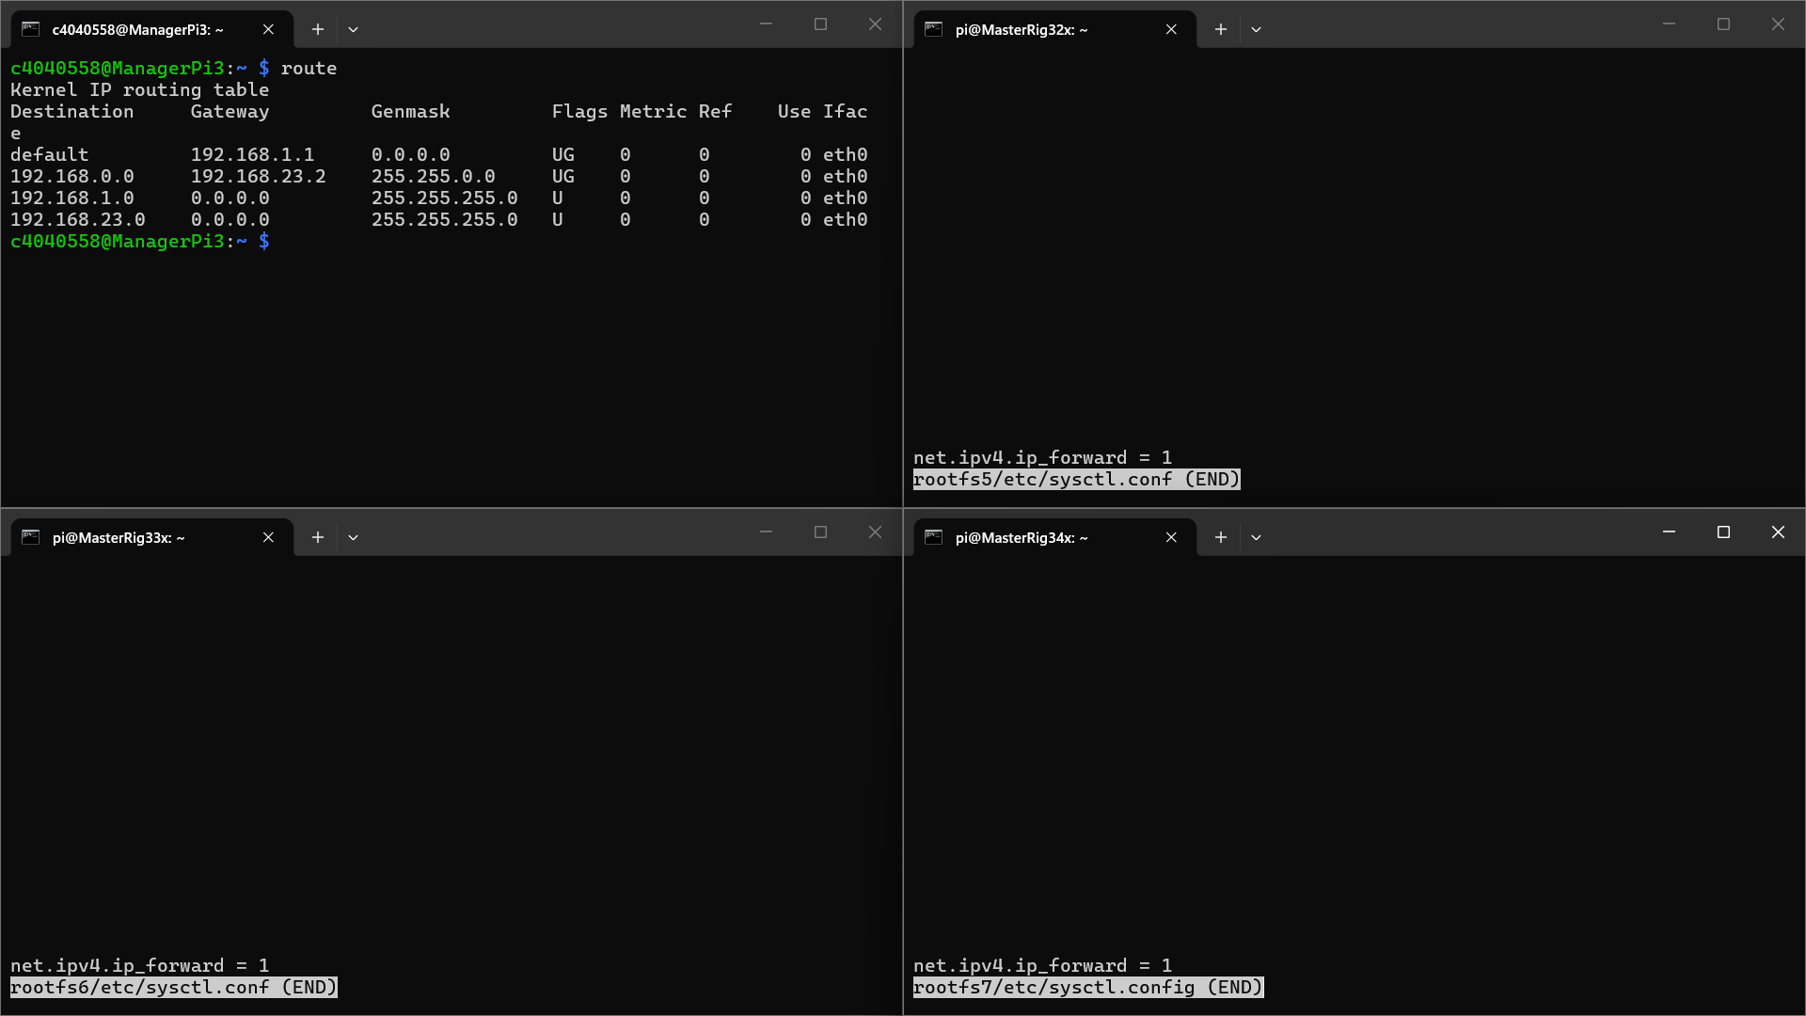
Added statements to allow Packet Redirecting between the rigs
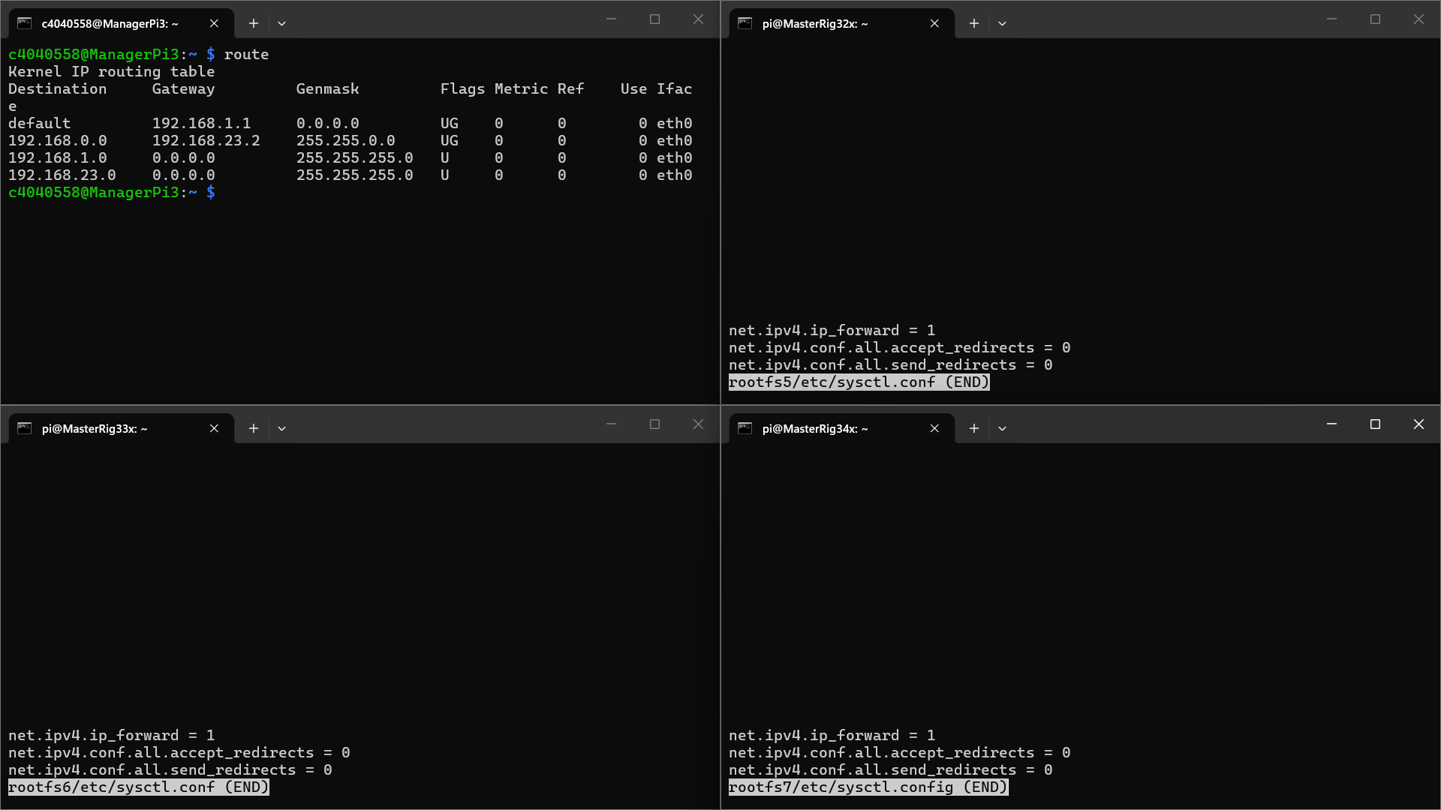
Failed to connect all rigs upon rebooting into [MyRig] images
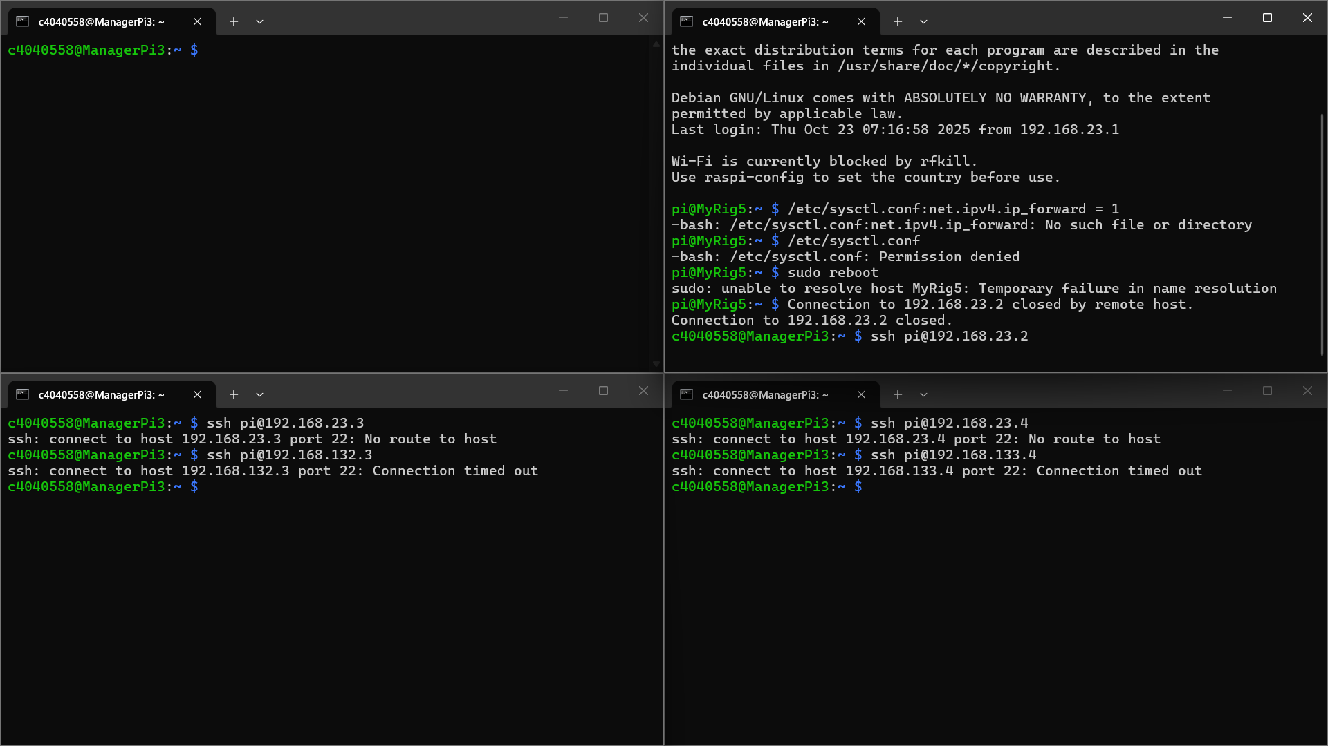
Tried fixing the routes with netmasks instead of specific IP addresses on [MyRig5]
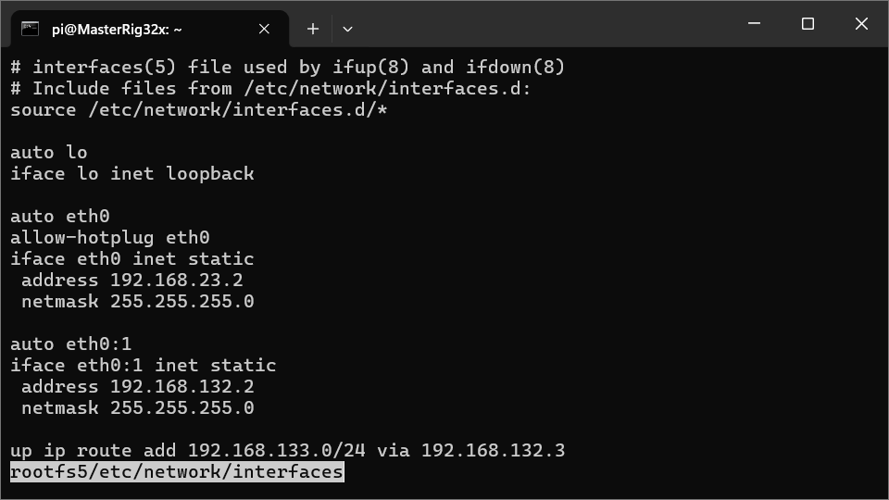
Successfully logged into [MyRig5] via [ManagerPi3]
Successfully logged into [MyRig6] via [MyRig5] and then into [MyRig7] via [MyRig6]
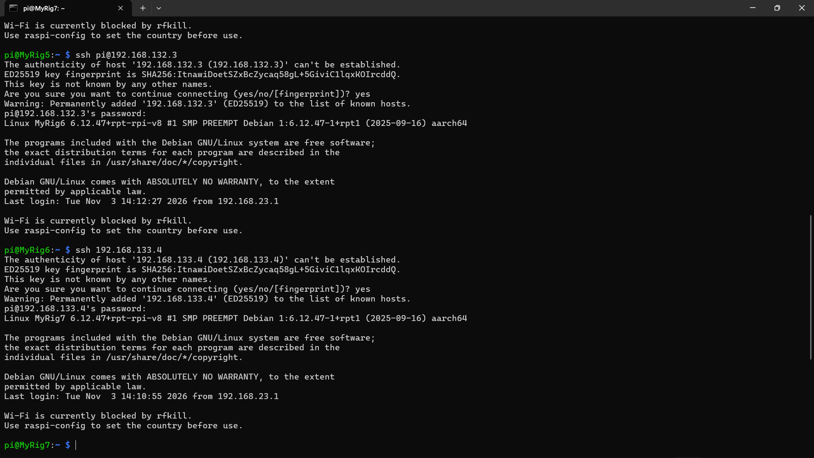
Unable to log into [MyRig6] and [MyRig7] directly via [ManagerPi3]
Current Network ssh connection possibilities with public keys shared:
[ManagerPi3] [MyRig5] {[MyRig6], [MyRig7] – Connection timed out}
[MyRig5] [MyRig6], [MyRig7]
[MyRig6] [MyRig7] {[MyRig5] – Network is unreachable*}
[MyRig7] [MyRig6] {[MyRig5] – Network is unreachable*}
*Network is probably unreachable as it is a circular access – need to figure out a way to circumvent this – maybe using IP aliases will work
Spoiler Alert: IT DOES WORK – need to use the right IP addresses based on the LAN or the gateway connections present on each individual rig
Following is the updated (and detailed) table using aliases for connections (rather, using the IP address that is listed on the LAN or the gateway that it has access to – Netmask [255.255.255.0]):
Parent | [ManagerPi3] | [MyRig5]  [MasterRig32x] |  | [MyRig6]  [MasterRig33x] |  | [MyRig7]  [MasterRig34x]
Parent | 192.168.23.1 | 192.168.23.2  [eth0] | 192.168.132.2  [eth0:1] | 192.168.132.3  [eth0] | 192.168.133.3  [eth0:1] | 192.168.133.4
[ManagerPi3] | NA | ✔️ | ✔️ | X* | X* | X*
[MyRig5] | X | NA | NA | ✔️ | ✔️ | ✔️
[MyRig6] | X | X* | ✔️ | NA | NA | ✔️
[MyRig7] | X | X* | ✔️ | ✔️ | ✔️ | NA
*These connections need fixing – might be syntax errors in the config files
Distributed the SSH Keys between all possible connections to facilitate seamless access

04/11/2026
Generated a flow diagram to define the network (using the integrated Copilot tool on Microsoft Word):
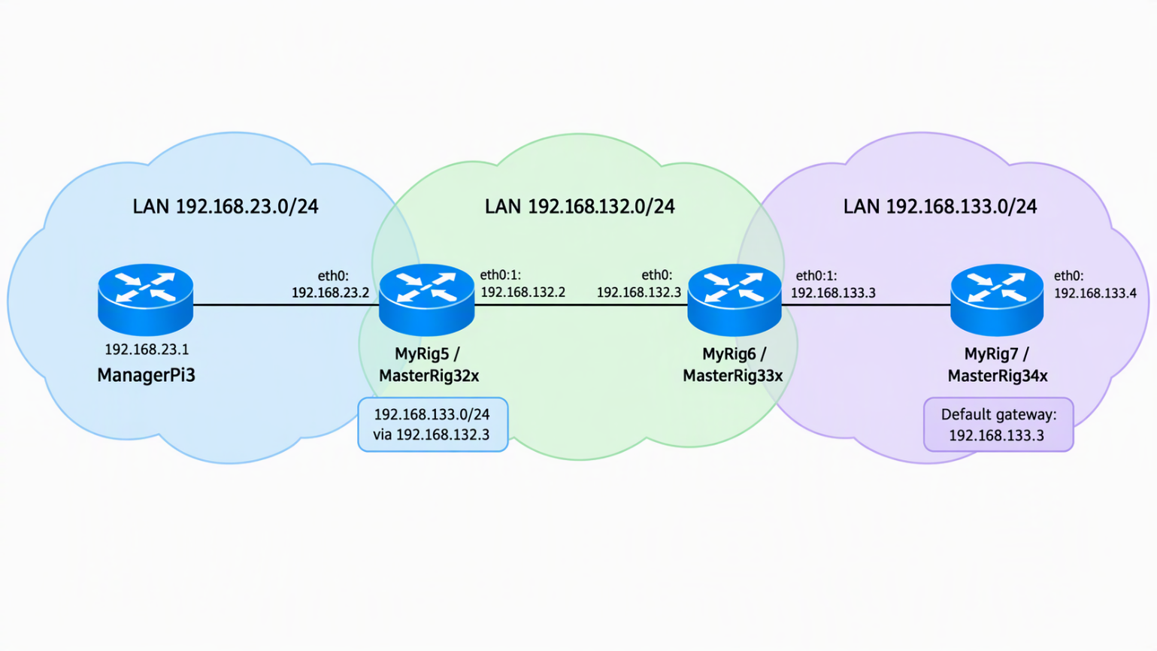
Fixed the connections between [MyRig6]/[MyRig7] and [MyRig5] via the “23” LAN line – there was an error in the routing table config files
Fixed issues with configurations on [MyRig7] – “sysctl.conf” file was wrongly named as “sysctl.config”, crippling the system
Updated routes are as follows:
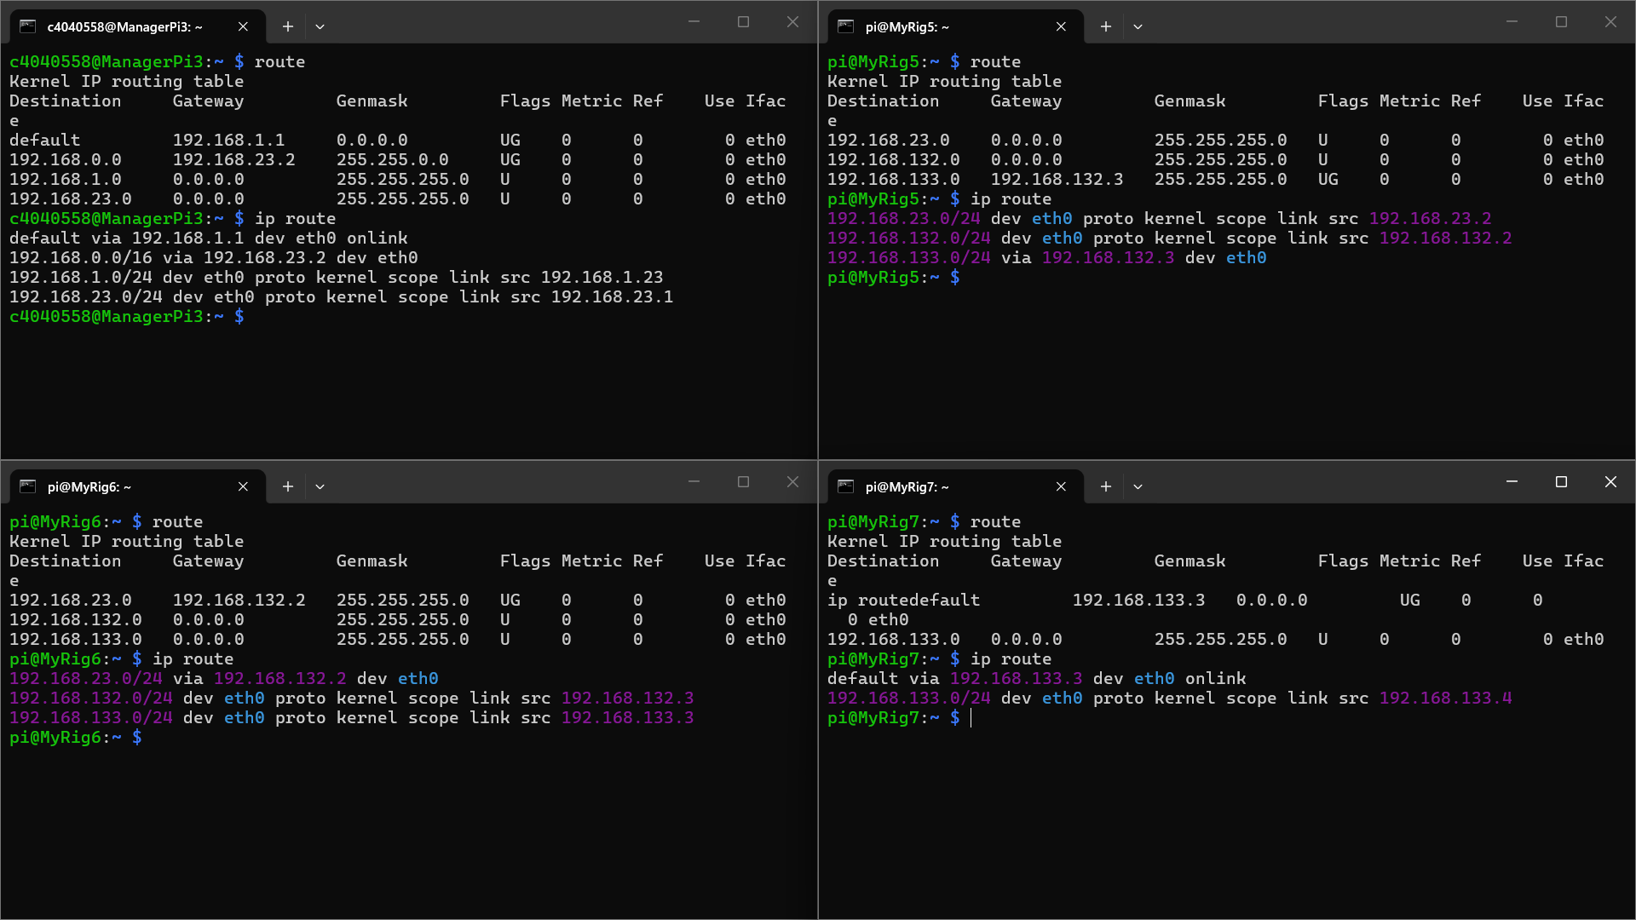
Updated routing table as follows:
Parent | [ManagerPi3] | [MyRig5]  [MasterRig32x] |  | [MyRig6]  [MasterRig33x] |  | [MyRig7]  [MasterRig34x]
Parent | 192.168.23.1 | 192.168.23.2  [eth0] | 192.168.132.2  [eth0:1] | 192.168.132.3  [eth0] | 192.168.133.3  [eth0:1] | 192.168.133.4
[ManagerPi3] | NA | ✔️ | ✔️ | ✔️ | ✔️ | ✔️
[MyRig5] | X | NA | NA | ✔️ | ✔️ | ✔️
[MyRig6] | X | ✔️ | ✔️ | NA | NA | ✔️
[MyRig7] | X | ✔️ | ✔️ | ✔️ | ✔️ | NA
Updated diagram is as follows (using the integrated Copilot tool on Microsoft Word):
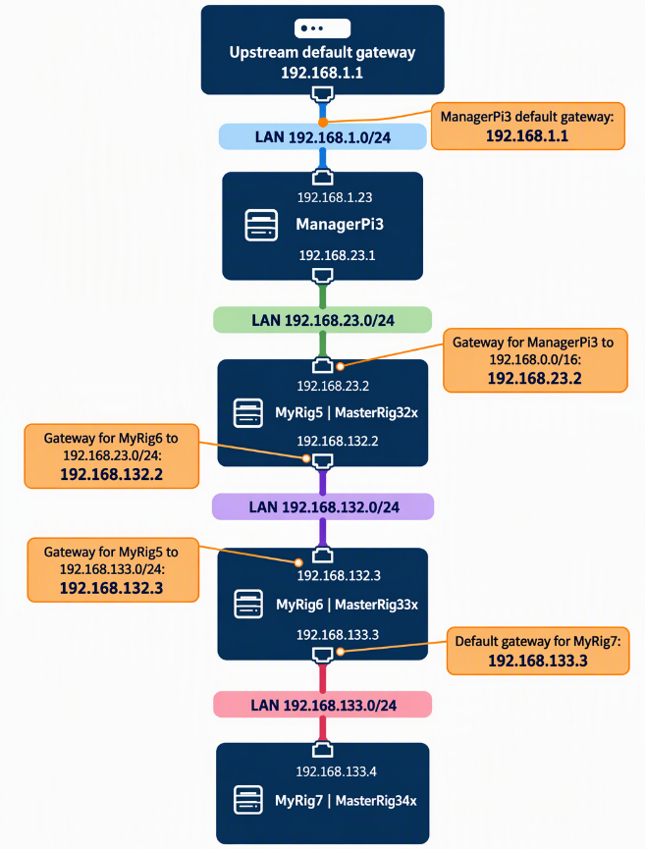
Ran tests on [ManagerPi3] to verify internet connectivity using exemplar probing commands:
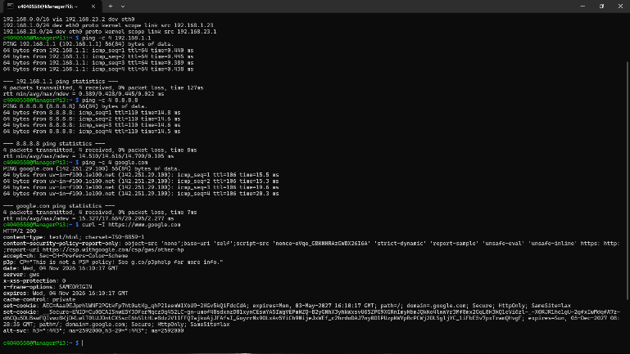
Following are the commands used:
Test | Reason
ping -c 4 192.168.1.1 | Gateway Connectivity
ping -c 4 8.8.8.8 | Worldwide IP Connectivity
ping -c 4 google.com | DNS Resolution
curl -I https://www.google.com | HTTPS Access
Used [route add -net 192.168.1.0 netmask 255.255.255.0 gw 192.168.23.1] to add a gateway on [MyRig5] for internet access within [/etc/rc.local]
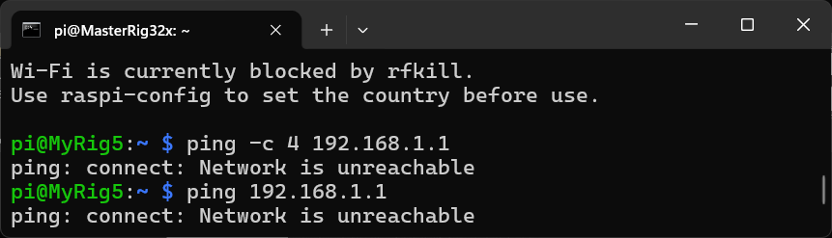
Failed to access [192.168.1.1] using this method from [MyRig5] – need to fix and understand and utilize “Maquerade” commands as well as “Postrouting” to be able to access the internets

05/11/2026
Ran [sudo tcpdump -e -n -i eth0 > tcpdmp.txt] on each of the rigs
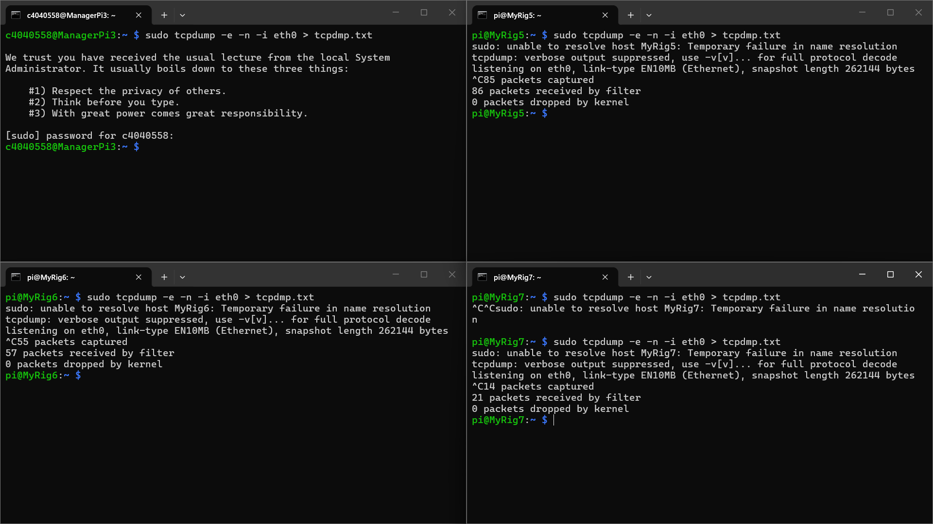
Successfully captured packets in each file, as per [Lecture 2 The Internet-1.pdf - https://ncl.instructure.com/courses/70671/files/11064576?wrap=1]
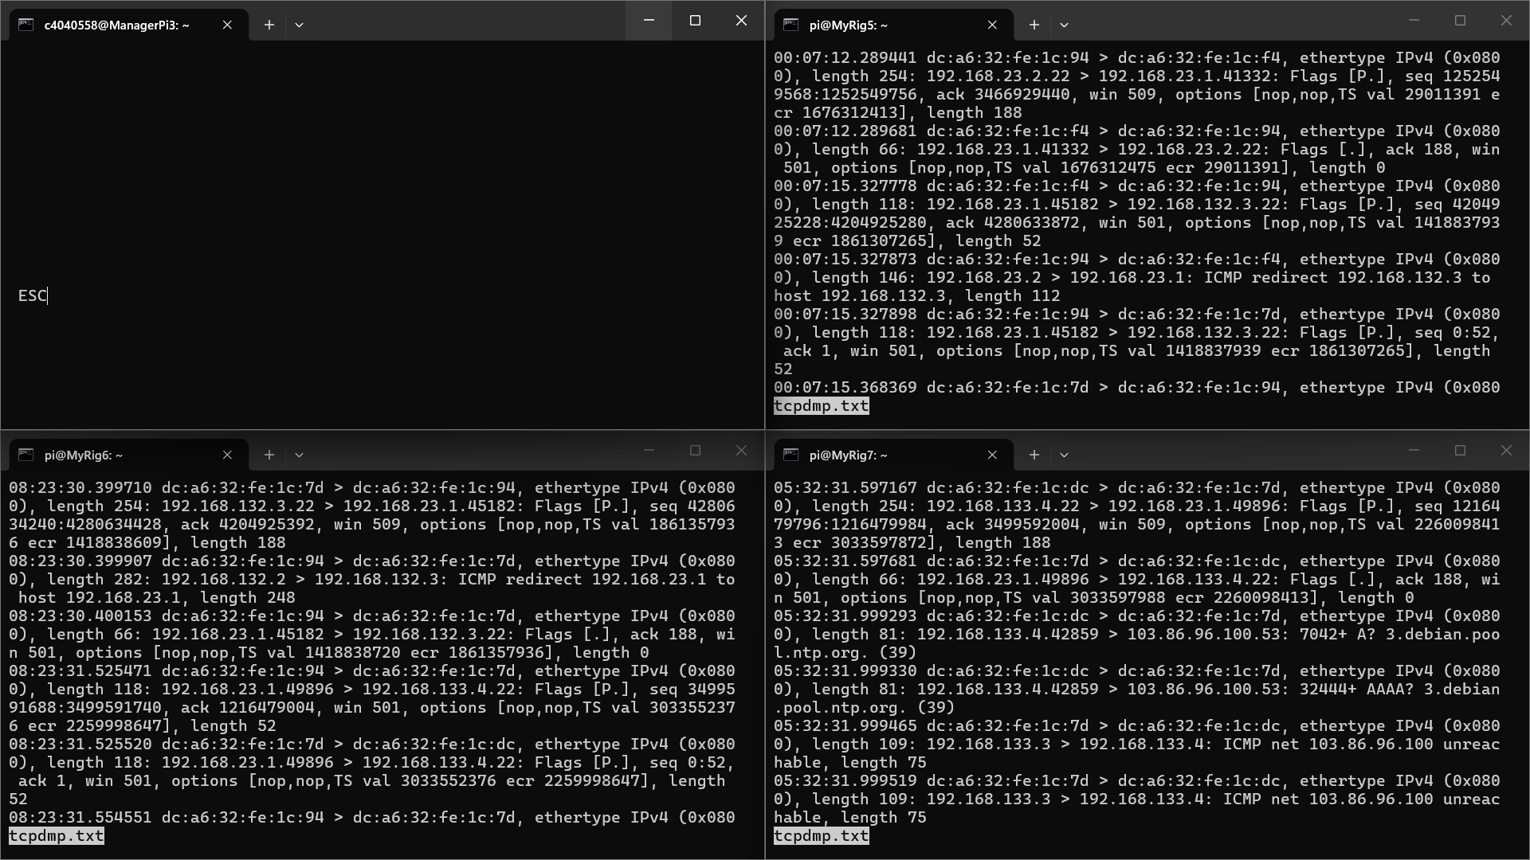
Pinged all possible rig combinations to measure latency in the network using [ping -c 4 <ip_address>] over the 4 RTT(s) (one example provided as a picture):
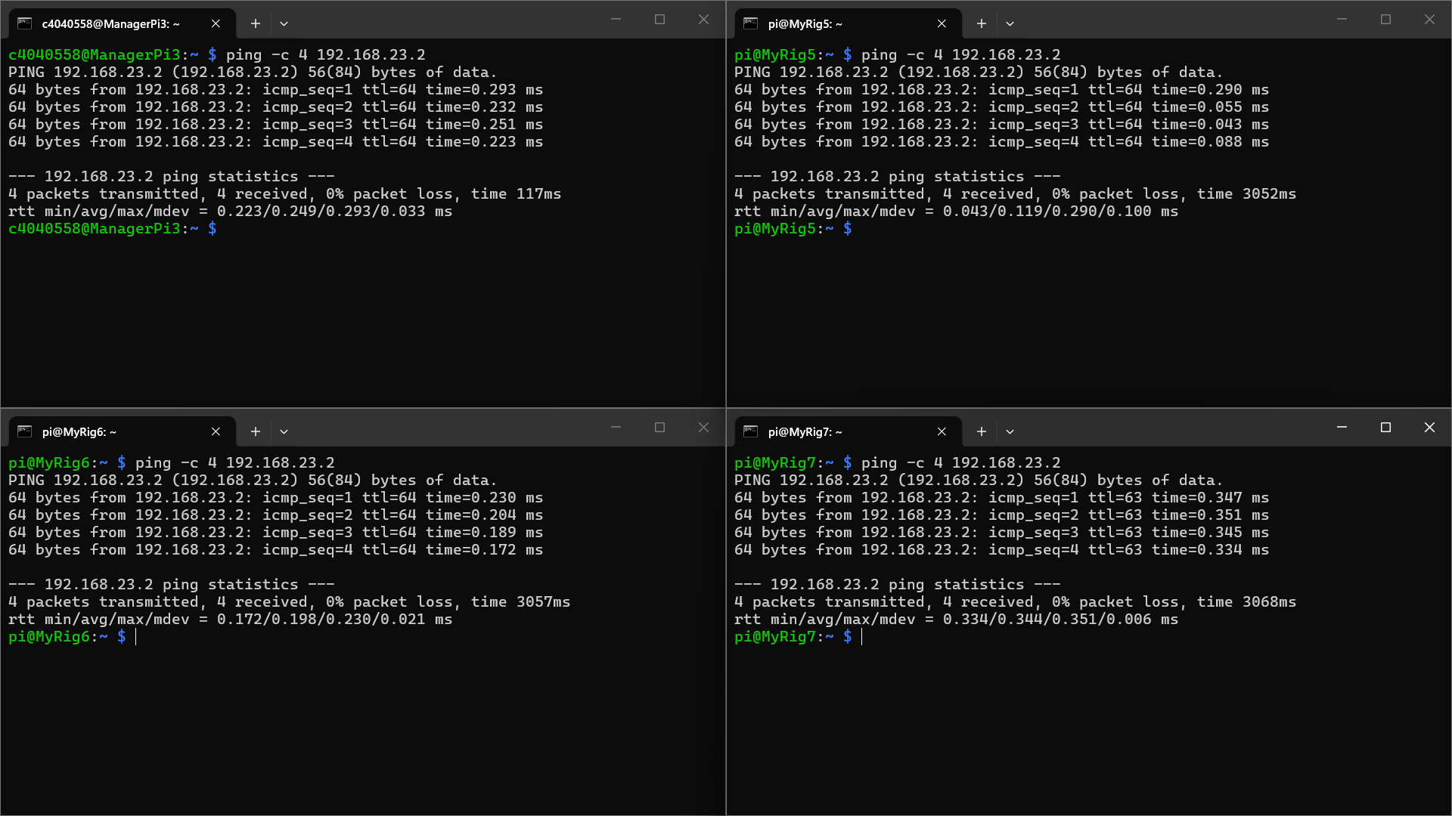
Built a latency table for all possible rig combinations as follows:
Parent | [ManagerPi3] | [MyRig5]  [MasterRig32x] |  | [MyRig6]  [MasterRig33x] |  | [MyRig7]  [MasterRig34x]
Parent | Min (ms)  Avg (ms)  Max (ms)  MDev/Jitter (ms)
Parent | 192.168.23.1 | 192.168.23.2  [eth0] | 192.168.132.2  [eth0:1] | 192.168.132.3  [eth0] | 192.168.133.3  [eth0:1] | 192.168.133.4
[ManagerPi3] | 0.082  0.101  0.138  0.024 | 0.223  0.249  0.293  0.033 | 0.232  0.265  0.334  0.041 | 0.371  0.411  0.448  0.031 | 0.420  0.480  0.635  0.093 | 0.580  0.613  0.678  0.049
[MyRig5] | 0.240  0.246  0.255  0.006 | 0.043  0.119  0.290  0.100 | 0.042  0.055  0.077  0.013 | 0.181  0.197  0.236  0.022 | 0.175  0.205  0.251  0.028 | 0.368  0.400  0.432  0.032
[MyRig6] | 0.400  0.433  0.455  0.024 | 0.172  0.198  0.230  0.021 | 0.183  0.202  0.225  0.014 | 0.039  0.064  0.123  0.034 | 0.038  0.061  0.114  0.030 | 0.201  0.211  0.222  0.007
[MyRig7] | 0.521  0.556  0.589  0.027 | 0.334  0.344  0.351  0.006 | 0.374  0.390  0.415  0.015 | 0.182  0.211  0.241  0.026 | 0.204  0.220  0.235  0.014 | 0.040  0.068  0.146  0.045
Added nameservers [8.8.8.8] and [8.8.4.4] into [rootfs*/etc/resolv.conf] on [MyRig*] (* - 5/6/7) for DNS resolution
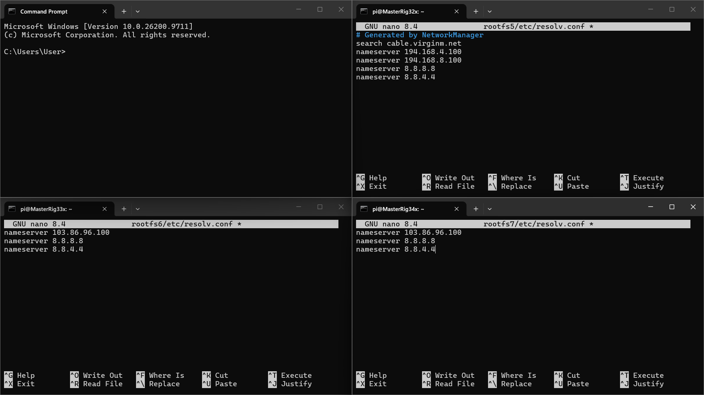
Made another small change to [MyRi6] – made the gateway [192.168.133.2] from ([MyRig5]) as default – making this gateway specific to [192.168.23.0/24] resulted in not being able to access [192.168.1.0/24], thereby restricting access to the internet (WWW) via [MyRig5]
Successfully verified connections to [8.8.8.8] and [8.8.4.4] with [ping -c 4 <ip_address>]
Successfully verified connections to Google with [ping -c 4 google.com] and [curl -I https://www.google.com]
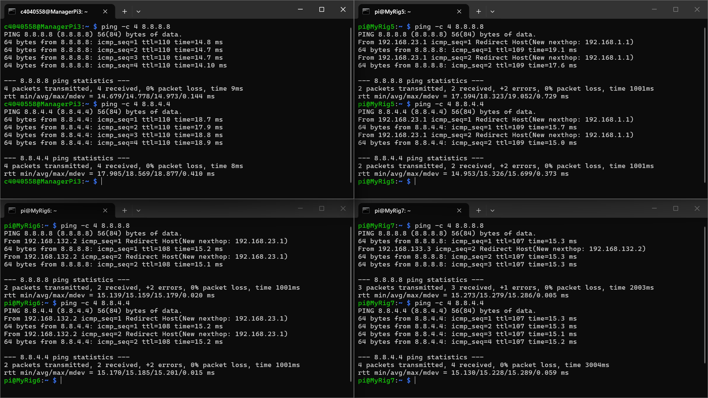
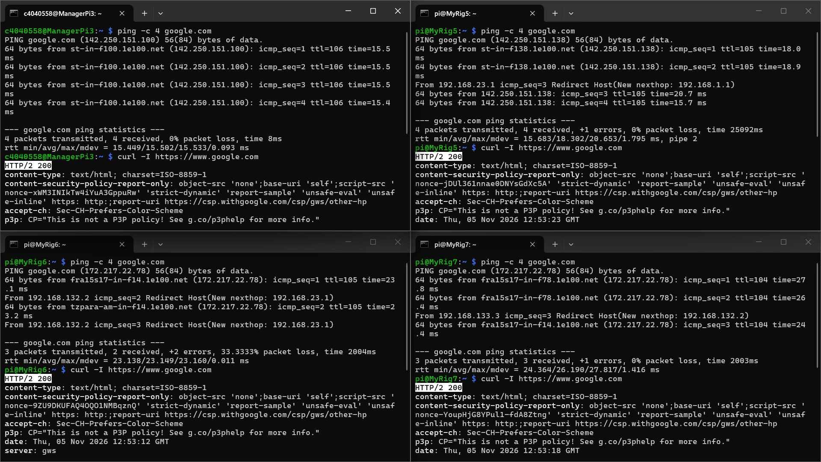
Observed loss of packets and some significant delays in this test alongside errors
Ran tests on each of the rigs to test for packet losses and errors over many pings (approx. 100), three times – table is as follows:
Test  [File] | [MyRig5]  [MasterRig32x]  TPkt/RPkt/LPkt(%)/Err | [MyRig6]  [MasterRig33x]  TPkt/RPkt/LPkt(%)/Err | [MyRig7]  [MasterRig34x]  TPkt/RPkt/LPkt(%)/Err
pingfile1.txt | 100/73/27/1 | 93/93/0/7 | 93/93/0/7
pingfile2.txt | 99/99/0/1 | 93/93/0/7 | 100/100/0/0
pingfile3.txt | 99/99/0/1 | 93/93/0/7 | 100/100/0/0
Observed that the number of “Redirect Host” sequences are the exact same as the number of errors in each test – [ManagerPi3] having redirects enabled could potentially be the issue
Tried using RS232 to connect to the motor via [MyRig5] as per [Practicals - https://ncl.instructure.com/courses/70671/pages/practicals?module_item_id=4340731]
Verified that [/dev/serial0] was present on [MyRig5]
Obtained “Superuser” status using [sudo su] on [MyRig5]
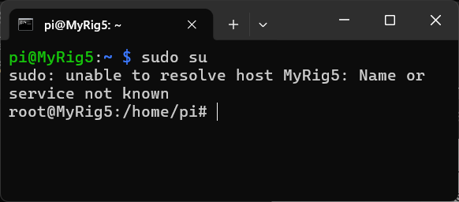
Used “minicom” to set the parameters using [minicom -s] – navigating to serial port setup and configuring the serial device to [/dev/serial0]; set BPS to 19200, 8-N-1 format and no sw or hw control
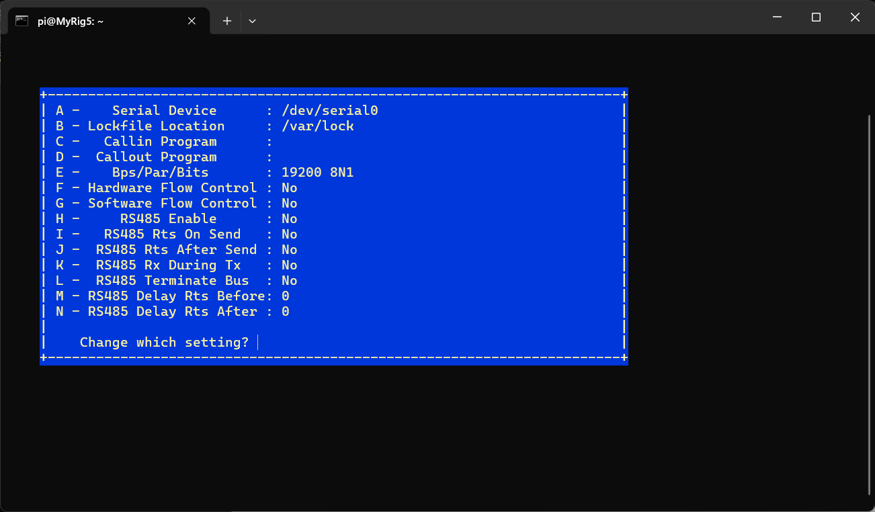
Saved this configuration as default (dfl) – allows loading into minicom directly without having to set up configurations on every reload
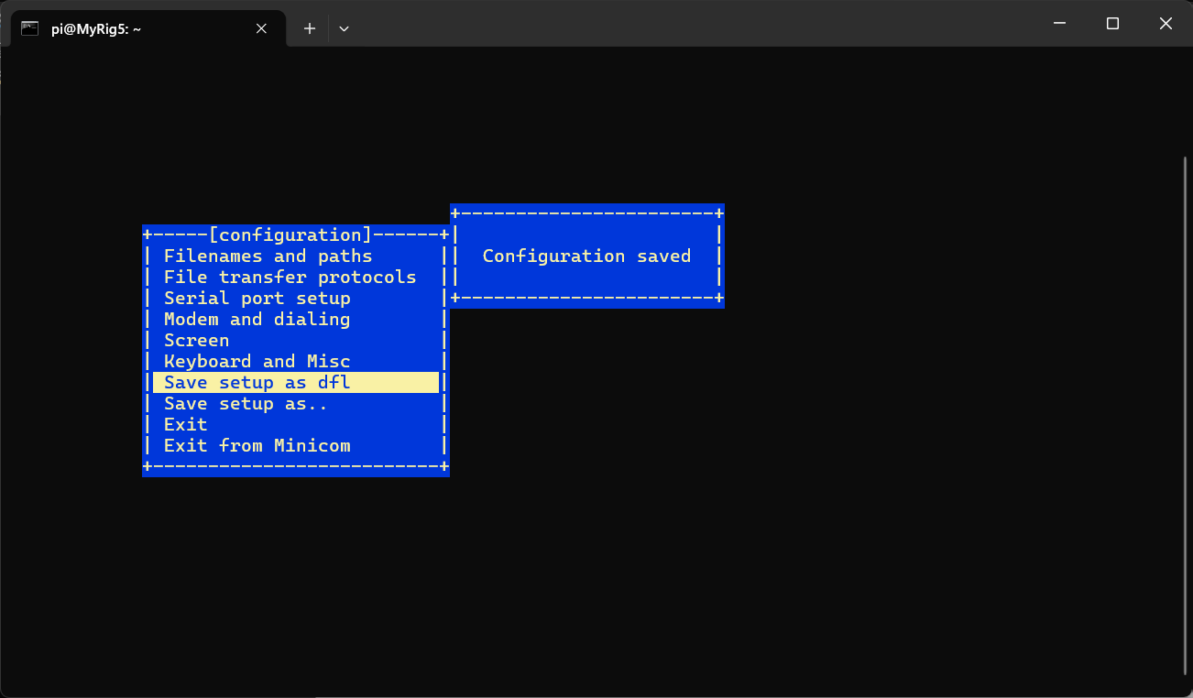
Tested the motor using [echo 900 1\\ > /dev/serial0]
Failed to run the motor – power supplies were off (in the lab)
Turned on the power supplies and tried to run the motor again
Failed – perhaps an issue with the configurations between the motor driver and [MyRig5]
Used [stty -F /dev/serial0] to check if the configurations were save and the baud rate was [19200] – they weren’t; baud rate remained at the old default [115200]
Figured out that the exit from minicom wasn’t happening through the right option, using “Exit from minicom” instead of “Exit” – loaded into a minicom screen with the right baud rate when “Exit” was used
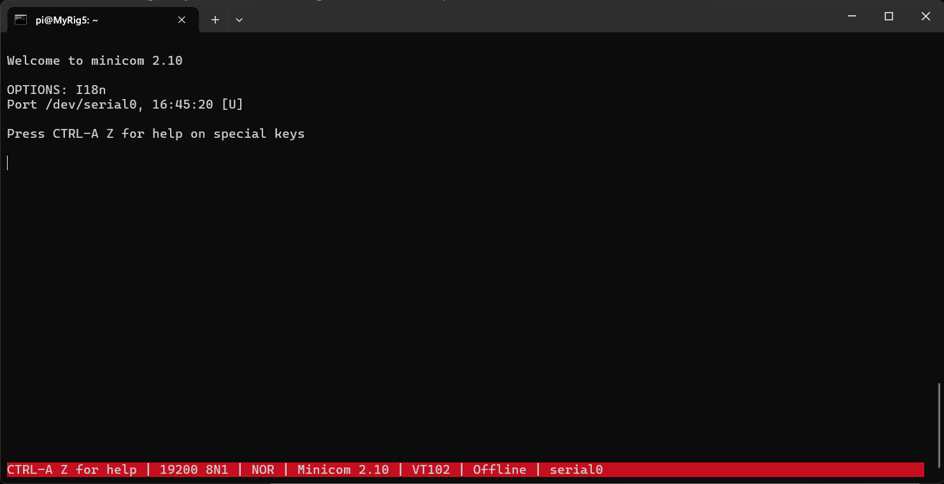
Successfully sent in serial communication on the minicom to activate the motor
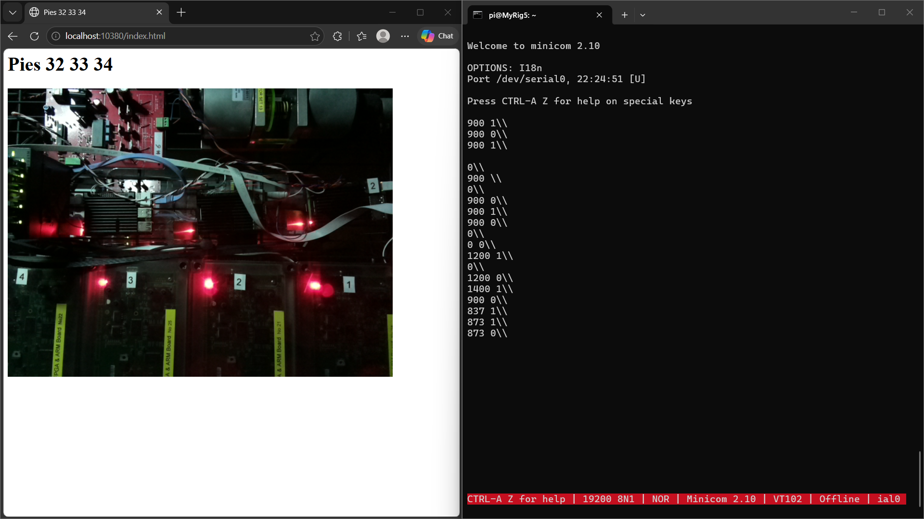

06/11/2026
Built a program [read_fifo.c] on [MyRig5] to read from a FIFO file
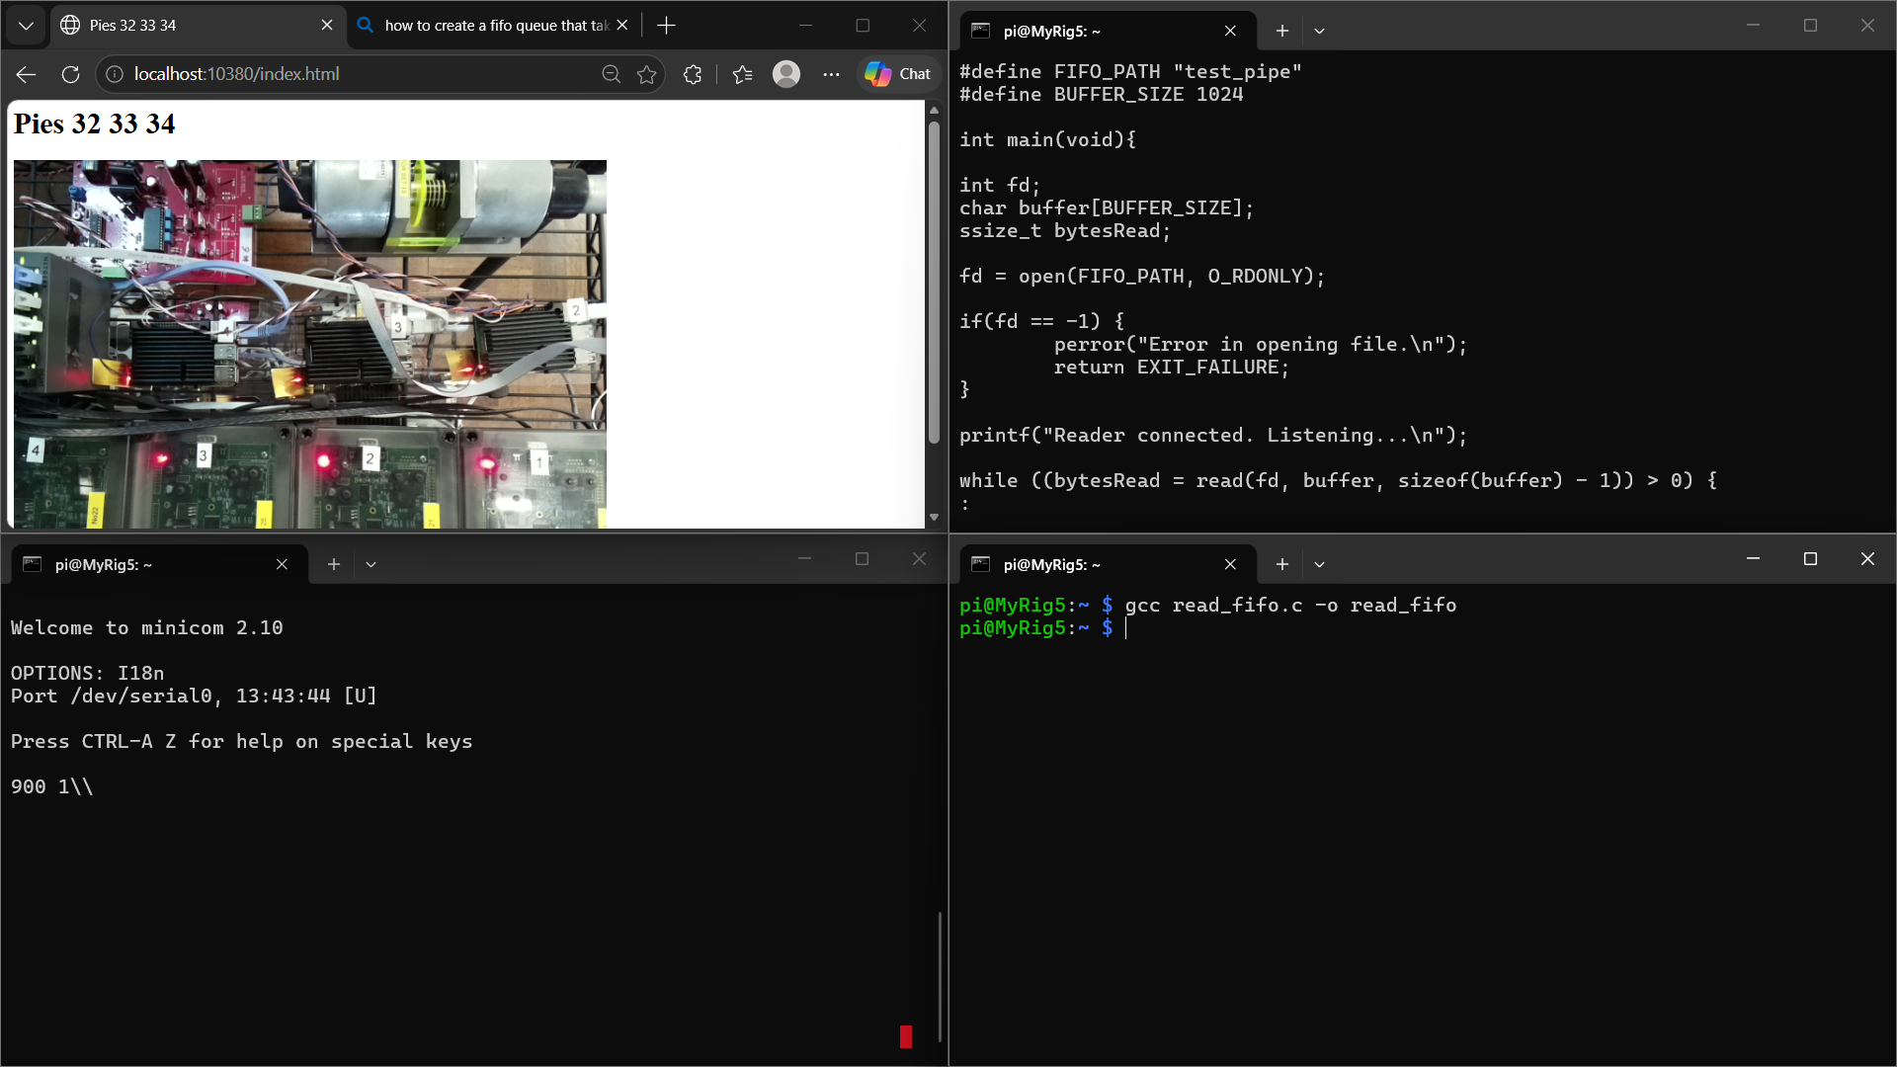
Created a FIFO file using [mkfifo] under the name [test_pipe]
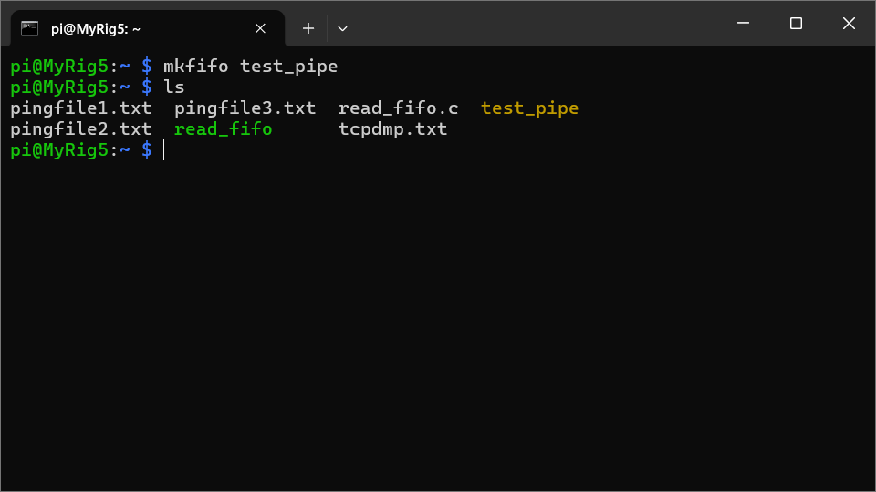
Ran [gpiomon GPIO9 > test_fifo] to load the FIFO file with data and ran the [read_fifo.c] program using [./read_fifo] to read and display the same while the motor ran with a serial input of [900 1\\] via minicom
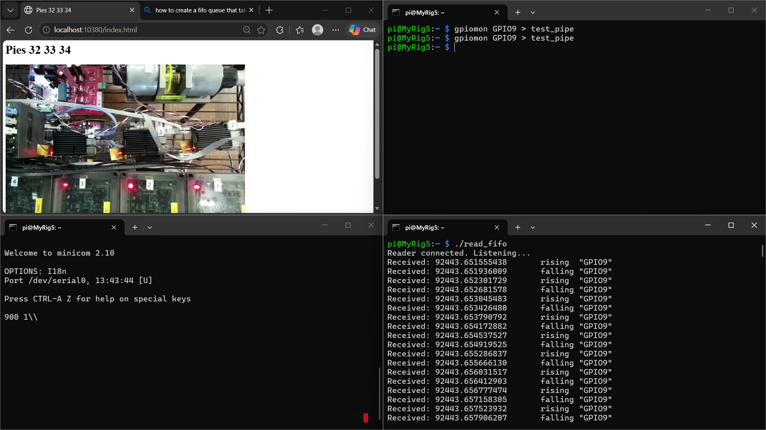
Created a [motor] directory using [mkdir] to store all the necessary files for running the motor
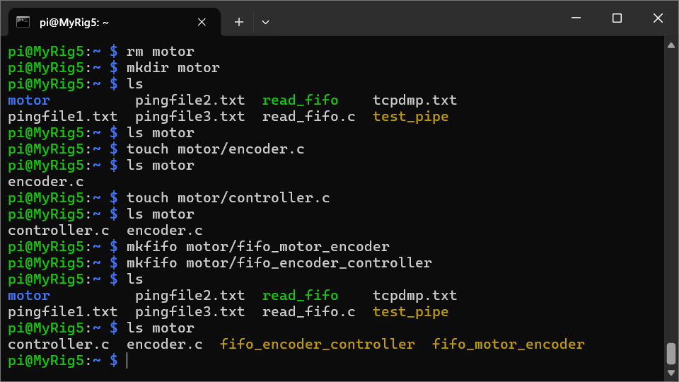
Current format of output using [gpiomon GPIO9 GPIO10] is as follows:
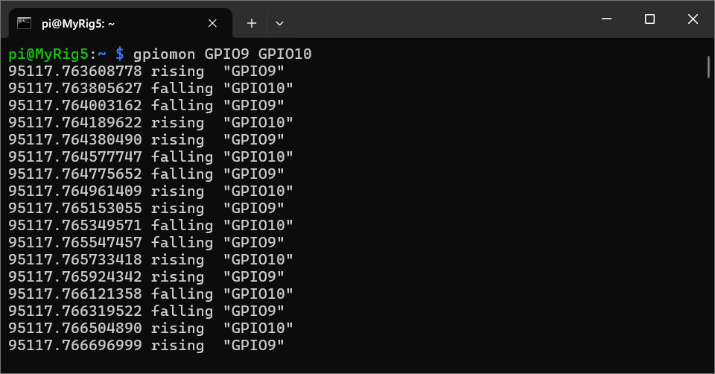
Formatted the output to have the edges defined as numbers using custom format specifications taken from the manual (found using [man gpiomon]) to obtain the output as follows:
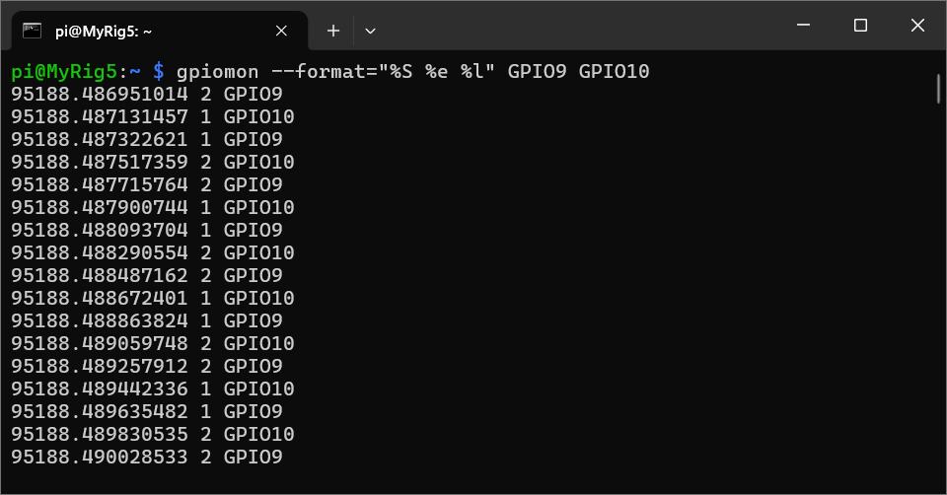
Pipelined a string substitution command using [sed 's/GPIO//g'] to remove “GPIO” so that the text can be typecast easier into numbers and obtained the output as follows:
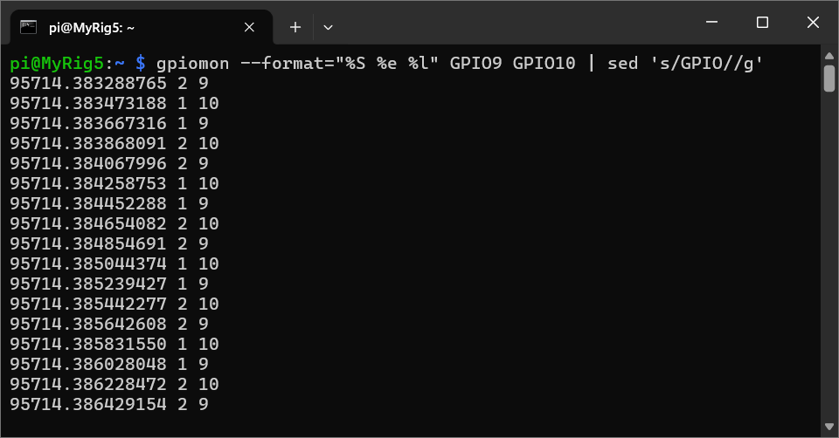
This formatted output will be sent into [/motor/fifo_motor_encoder] and read by the [motor/encoder.c] program to produce a real-time frequency measurement as output (measured over a specified duration)
This frequency measurement will in turn be read by the [/motor/controller.c] program via [/motor/fifo_encoder_controller] and the PID function will be performed
The output of the PID function will then be parsed into a shell command that will adjust the speed of the motor’s rotation and facilitate stabilization
Built [motor/encoder.c] and complied it using [gcc motor/encoder.c motor/encoder]
Used “<pthread.h>” header file for implementing multithreading
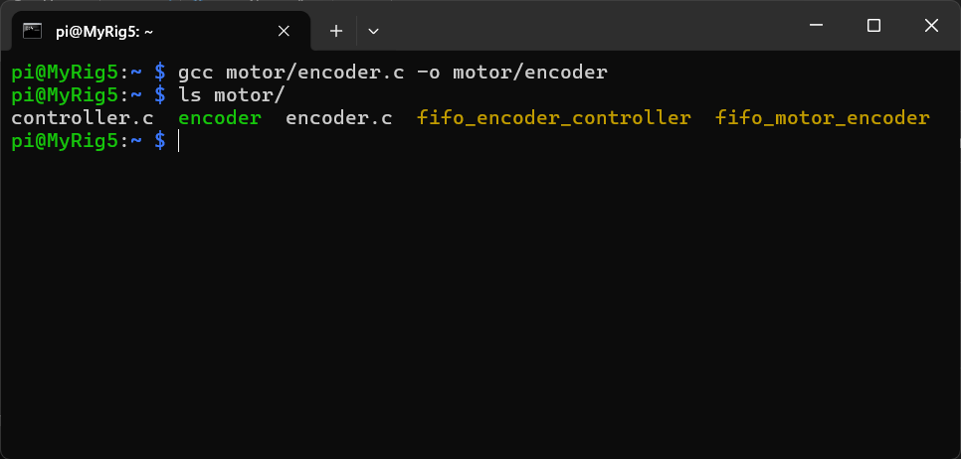
Encoder was tested for functionality and apparent accuracy with output directly being shown on the screen
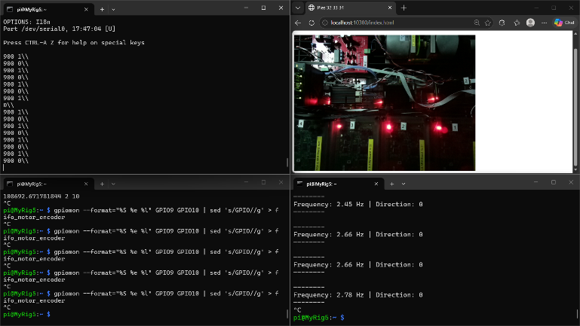

Ran another test with output being stored into a file [motor/encoder_output.txt] to obtain a log
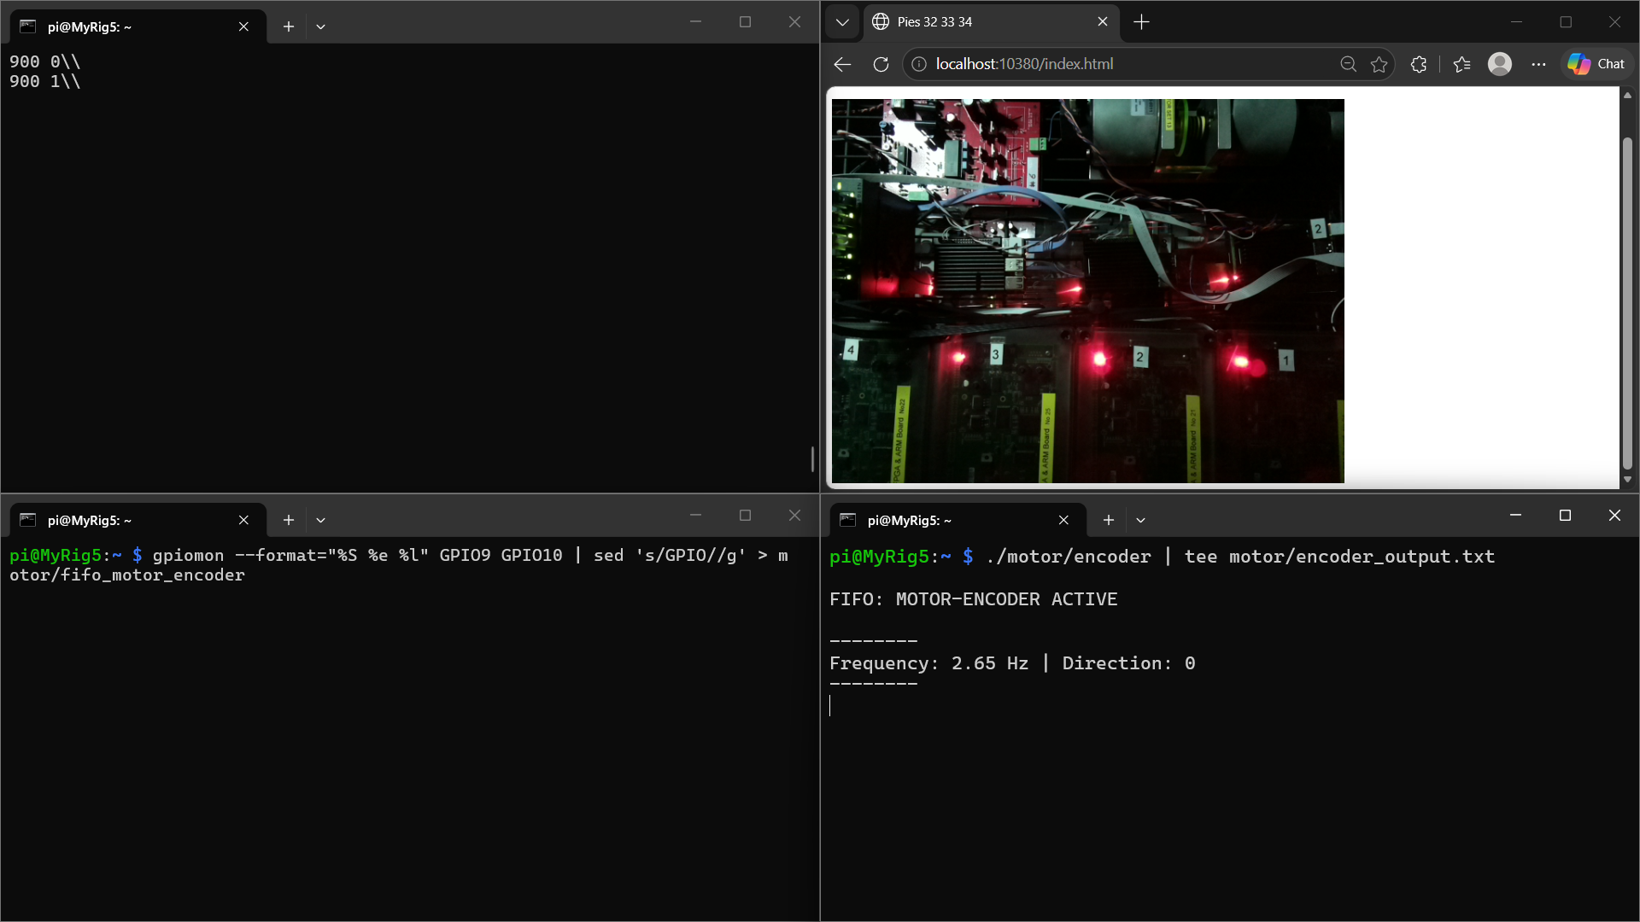
Opened the [motor/encoder_output.txt] file to verify contents
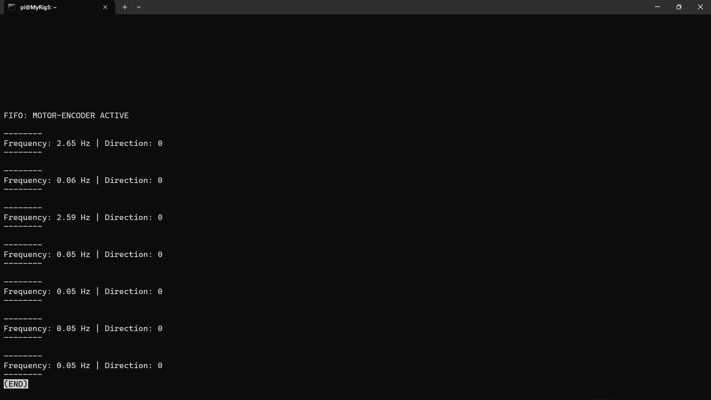
Observed changes in frequency as and when serial inputs were changed
Observed issues with direction not being calculated properly – stays at default value
This might be due to broken loops or unfortunate overwrites

07/11/2026
Fixed the broken loops and unfortunate overwrites
Also handled errors and loop terminations to facilitate graceful exits from each thread and in turn the parent program
Verified frequency measurements as well as direction calculations
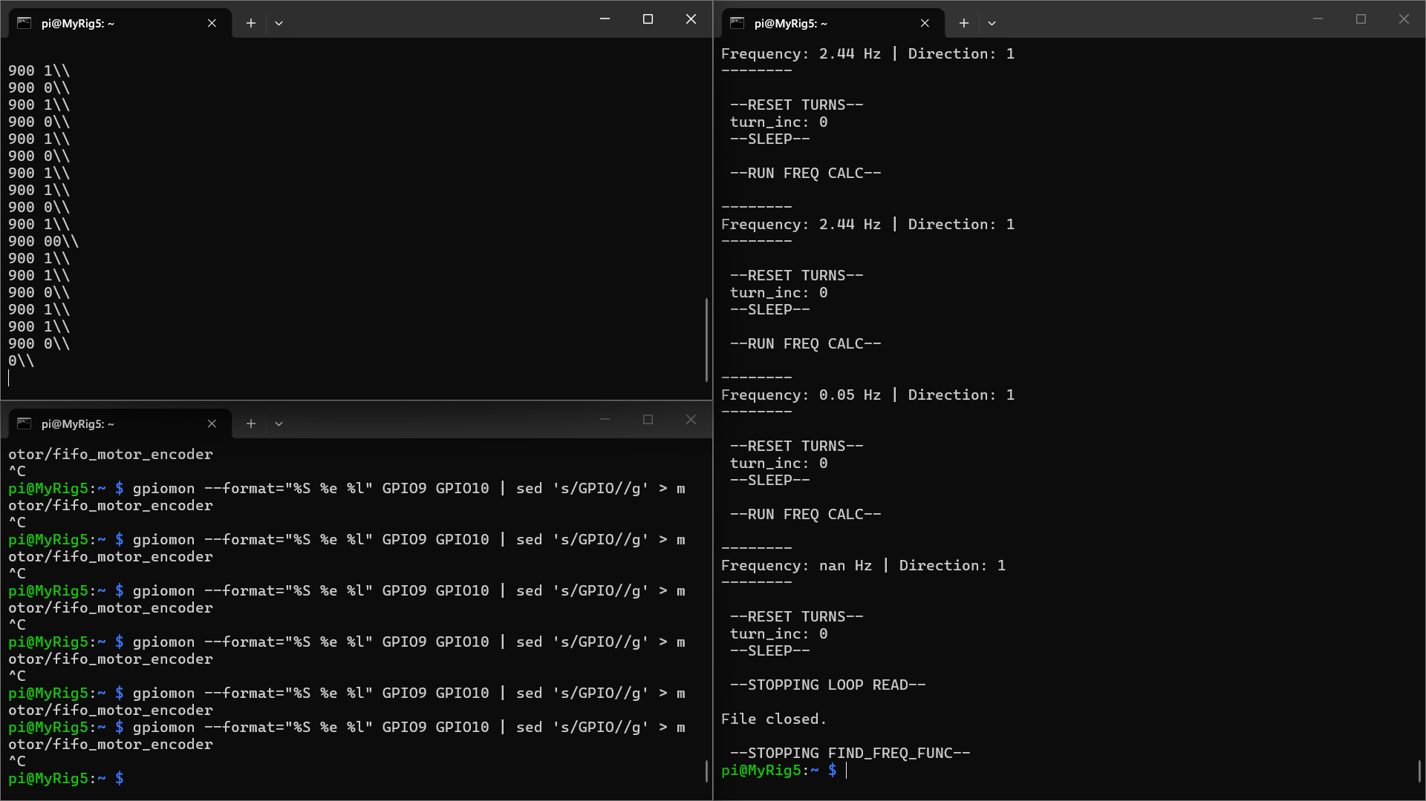
Understood the flow for the PID program to be built as [motor/controller.c] based on the information and guidelines present in [Controlling a DC Motor with Delay Study Notes (EEE8089).pdf - https://ncl.instructure.com/courses/70671/files/11092863?module_item_id=4346374]
Modified the [motor/encoder.c] program to have a well-formatted output be sent into a data capture file [motor/encoder_samples.dat] to capture the step response with the motor frequency being measured every 20ms
Verified the contents [timestamp_val freq turn_inc] of the sample file [motor/encoder_samples.dat]
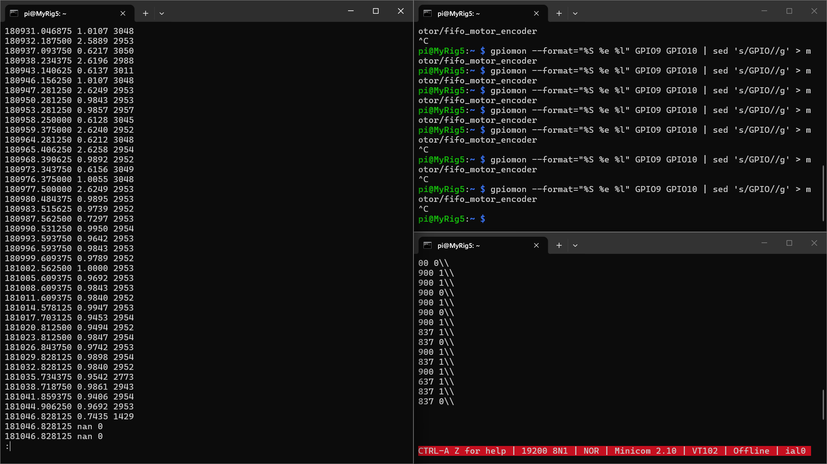
Uncovered a significant semantic error – the formula for calculating frequency had a missing set of brackets that mangled the output to the point where it looked believable but was garbage
Old formula: freq = ((float)turn_inc/(ENCODER_CUTS*2.0f)/(timestamp_val – timestamp_init_val))
Corrected formula: freq = (((float)turn_inc/(ENCODER_CUTS*2.0f))/(timestamp_val – timestamp_init_val))
Ran tests again, switching between running at [837 1\\] and stopping with [837 0\\] and verified the output
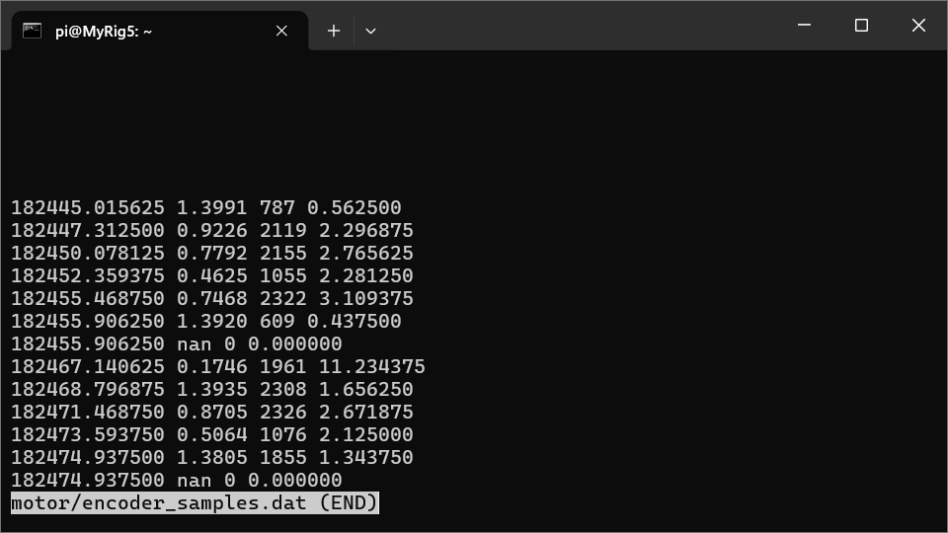
Uncovered another issue which was due to the “inc_func” loop blocking the “find_freq_func” loop and therefore having the “timestamp_val” variable be updated for a much larger number of times than necessary
Required no fix, as this was a self-correcting issue – “turn_inc” was also being incremented within the same loop that blocked “timestamp_val” which meant that the frequency was measured correctly, just over different spans of time
Fixed this to have the same span of time for each measurement by adding priority to the semaphores
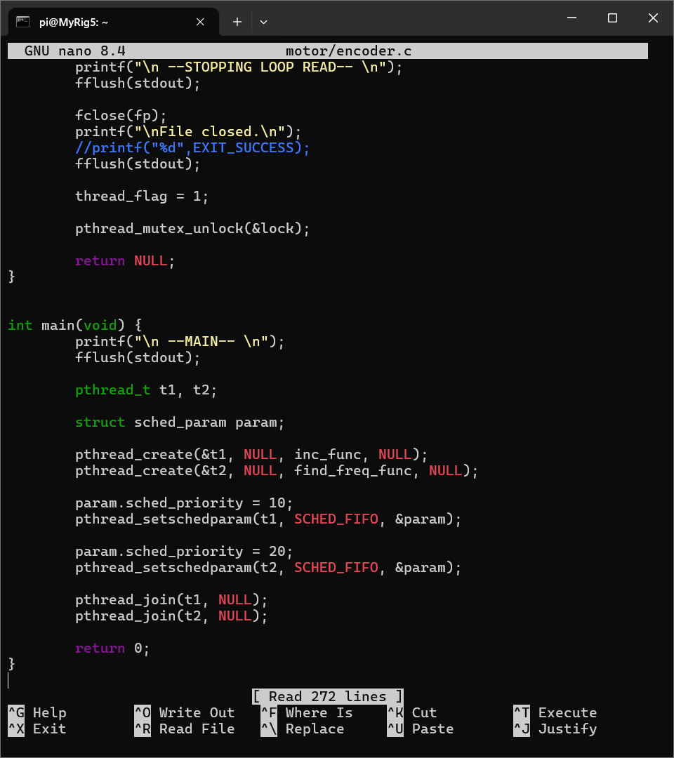
Ran the tests again to check if priority scheduling worked as intended
Priority scheduling failed, as sleep timer overrides priorities
Reverted to normal scheduling and used an “executed” flag to inhibit unnecessary calculations
Output was verified to be closely matching requirements
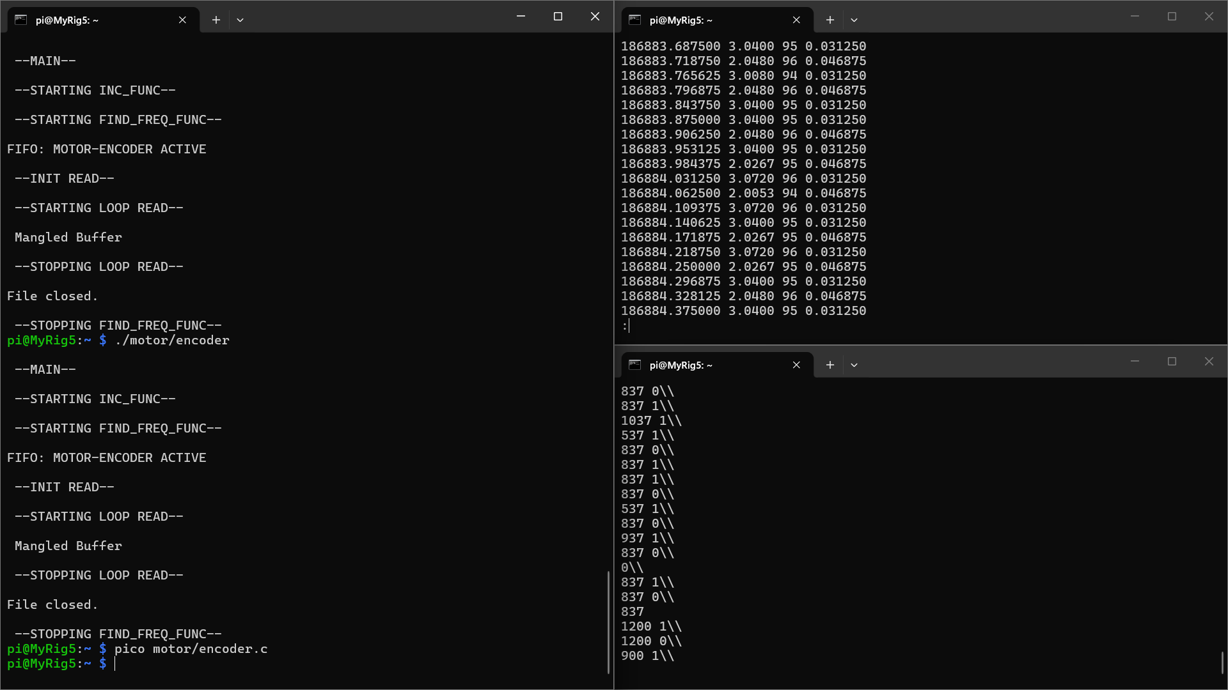
Modified the file output to have only the timestamps and frequency
Uncovered a terrible bug – frequency measurement fails when at 0Hz as the FIFO stops appending and “fgets()” just blocks the loop without a return value – this implies that a choice must be made from the following:
- Keep the conditions where 0Hz is measured and keep the race condition frequency measurements as they can’t be differentiated
- Remove both conditions – measurement fails to update at 0Hz
Neither option is an agreeable trade-off – code must be rebuilt with this bug in mind

08/11/2026
Rebuilt the [motor/encoder.c] program with a different style of file reading with the help of “poll()” on the FIFO file (now opened with a “O_NONBLOCK” directive) to obtain distinct readable conditions for when a file is open but empty and when a file is closed – allows the measurement to update as 0Hz whenever the file is found to be empty
Incorporated another flag to inhibit consecutive runs of the “find_freq_func” thread to block the race condition records
Ran a test for [motor/encoder.c] while cycling between [837 1\\] and [837 0\\] as the serial input to the motor
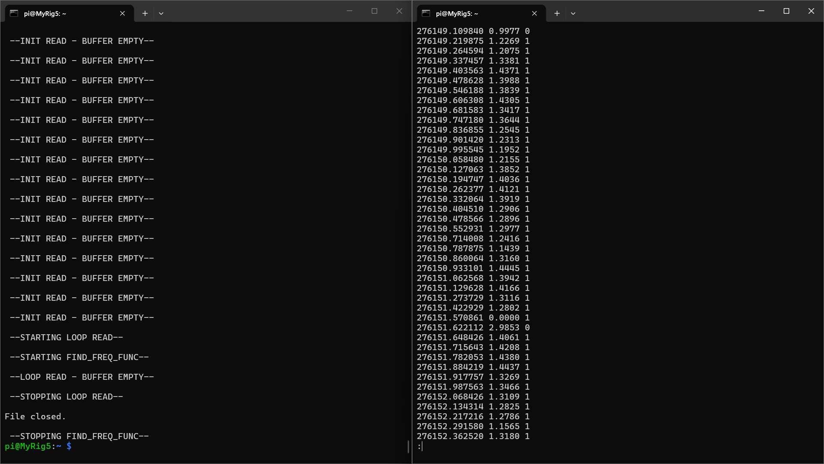
Took the data stored in [motor/encoder_samples.dat], plotted raw as well as processed data using a MatLab script [C:\Users\User\OneDrive\Documents\GitHub\NCL_GitHub\NCL\NCL Merz Court Computer Cluster\EEE8089\encoder_samples_plotter.m]
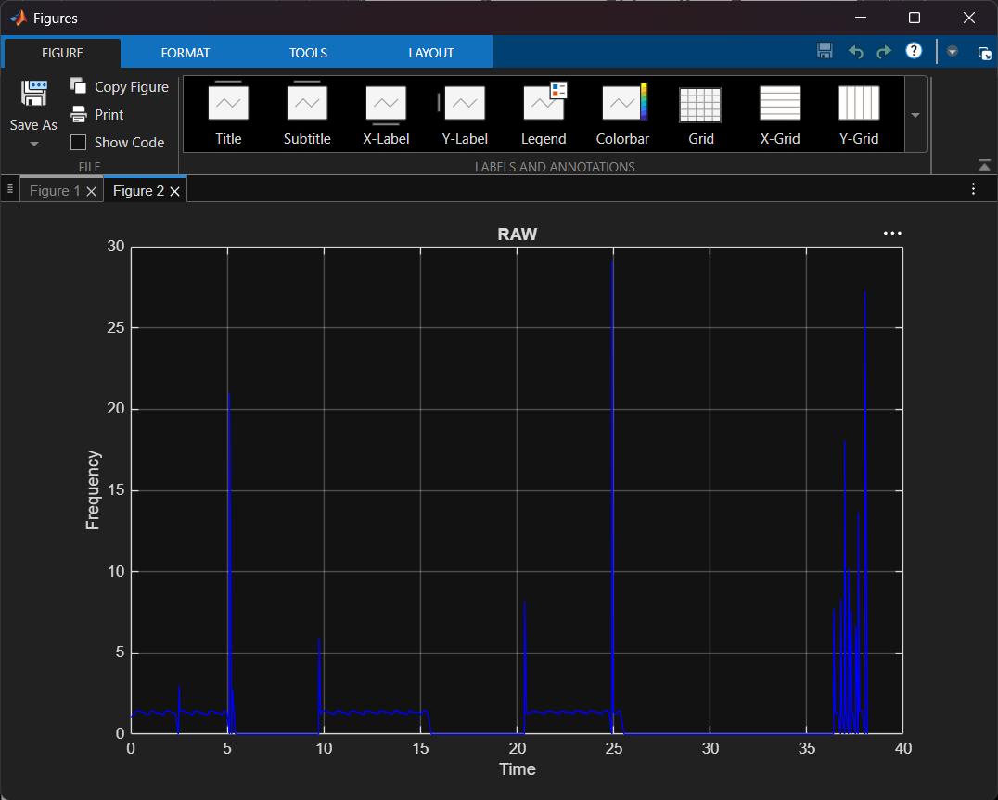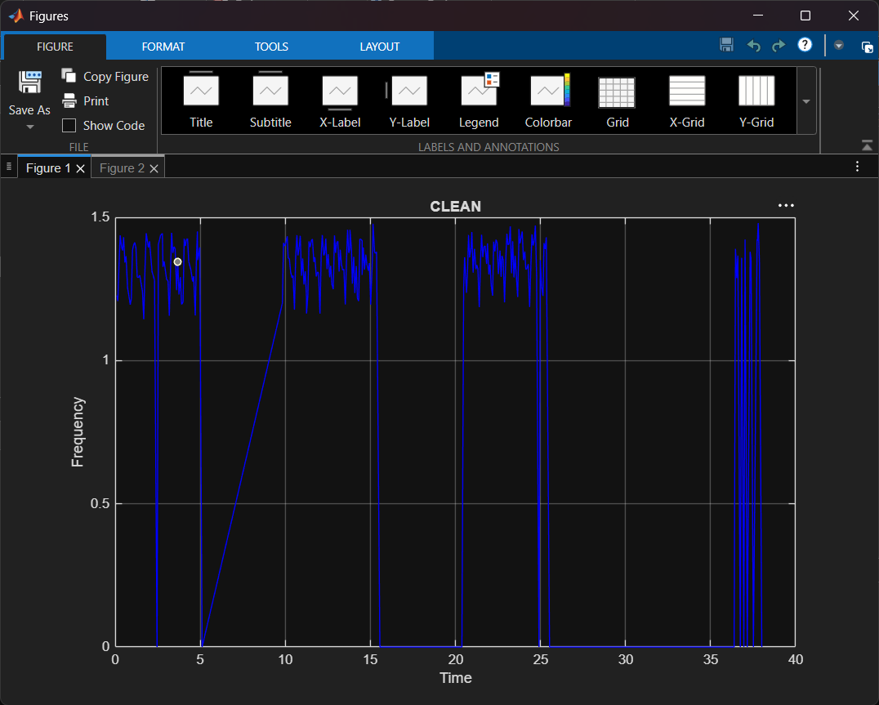
Observed the instability of the motor while it functions at a serial input of [873] – a PID controller program must be built to stabilize the motor in real-time

09/11/2026
Updated the network diagram to show nodes in the right way (using the integrated Copilot tool on Microsoft Word):
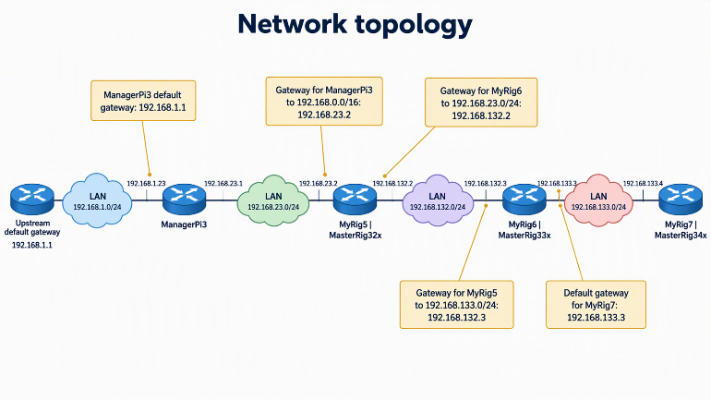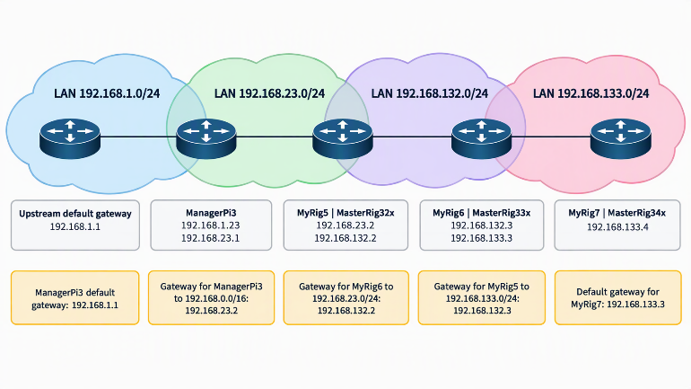
Shifted the [motor/encoder.c] file to [MyRig7], for implementing the remote encoder architecture as defined in [coursework2-1.pdf - https://ncl.instructure.com/courses/70671/pages/lectures?module_item_id=4340730] by copying the directory from [MyRig5] to [MyRig7] over the LAN
As the gpiomon readings are available on [MyRig5], this data needs to be sent over the network to [MyRig7] which can be done using [gpiomon --format="%S %e %l" GPIO9 GPIO10 | sed 's/GPIO//g' | ssh pi@192.168.133.4 “cat > ~/motor/fifo_motor_encoder;”] on [MyRig5]
But this doesn’t close the FIFO on [MyRig7] upon exit form [MyRig5] – fixed this by using [gpiomon --format="%S %e %l" GPIO9 GPIO10 | sed 's/GPIO//g' | ssh pi@192.168.133.4 'trap "rm ~/motor/fifo_motor_encoder EXIT"; mkfifo ~/motor/fifo_motor_encoder; cat > ~/motor/fifo_motor_encoder;'] on [MyRig5] to trap the interrupts from [MyRig5] and send the exit condition to [MyRig7]

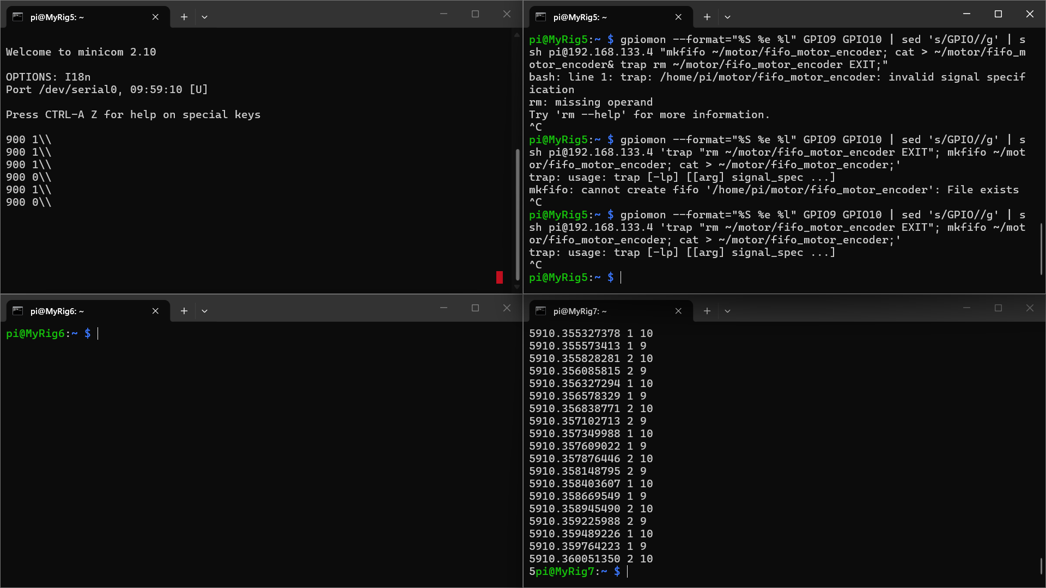
Modified the [motor/encoder.c] program (now on [MyRig7]) to send the output back to the [motor/encoder_controller] FIFO file on [MyRig5], for running the controller program to stabilize the motors
Neglected using trap, as it doesn’t work when the infinite loop of a program is running, reverted to using [gpiomon --format="%S %e %l" GPIO9 GPIO10 | sed 's/GPIO//g' | ssh pi@192.168.133.4 'cat > ~/motor/fifo_motor_encoder;']
Implemented the [motor/controller.c] program with the [motor/encoder_controller] FIFO connected to it and obtained relatively arbitrary outputs – this tested the connection and communication between the files when all the processes are hosted solely on [MyRig5]
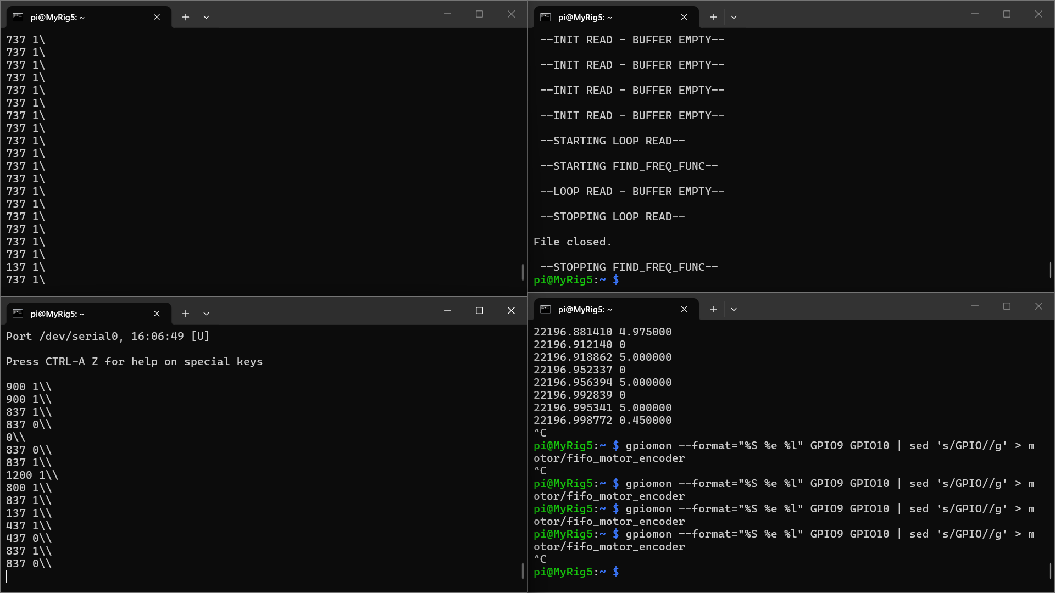
The controller must be modified to output values as per requirements at 1Hz control frequency and to handle the direction of rotation
Handled the cleaning of samples better to omit the miscalculated dips to 0 Hz due to program shortcomings – observed that “dir” can be used as a source of truth such that, if dir goes to 0 when “freq” is a non-zero value, this reading can be omitted along with the previous reading (which would surely have “freq” as 0 due to the way “dir” is calculated) – included processing step this in the [C:\Users\User\OneDrive\Documents\GitHub\NCL_GitHub\NCL\NCL Merz Court Computer Cluster\EEE8089\encoder_samples_plotter.m] MatLab script to obtain a cleaner plot
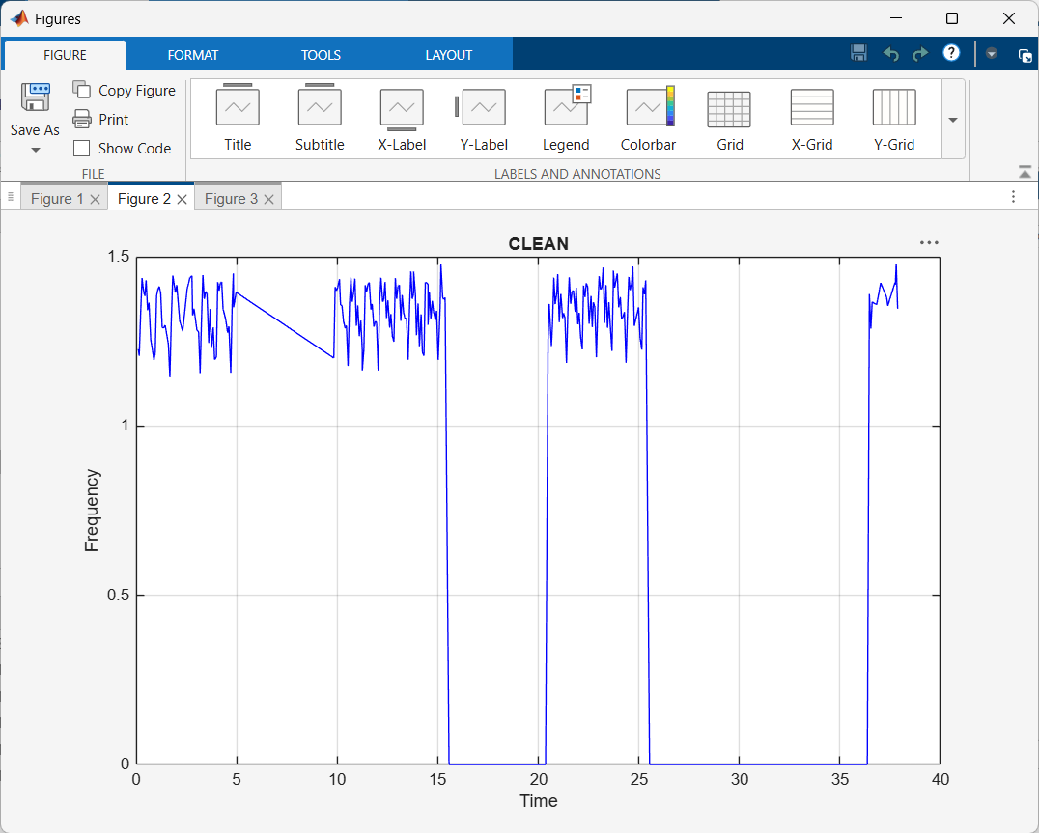

11/11/2026
Used MatLab with the Control System Toolbox installed to model the PID controller parameters for the motor
The motor is considered to be a slow, first-order system modelled by [G = K/((T*s) + 1)] as per [Controlling a DC Motor with Delay Study Notes (EEE8089).pdf - https://ncl.instructure.com/courses/70671/files/11092863?module_item_id=4346374]
(K – Motor Gain, T – Time Constant)
Modelled the open loop and closed loop behaviours using a MatLab script [C:\Users\User\OneDrive\Documents\GitHub\NCL_GitHub\NCL\NCL Merz Court Computer Cluster\EEE8089\PID_Controller_Parameters.m]
Started with a baseline of the standard unity gain [K = 1] system with [T = 0.5] and swept a Steep Response to study open loop response
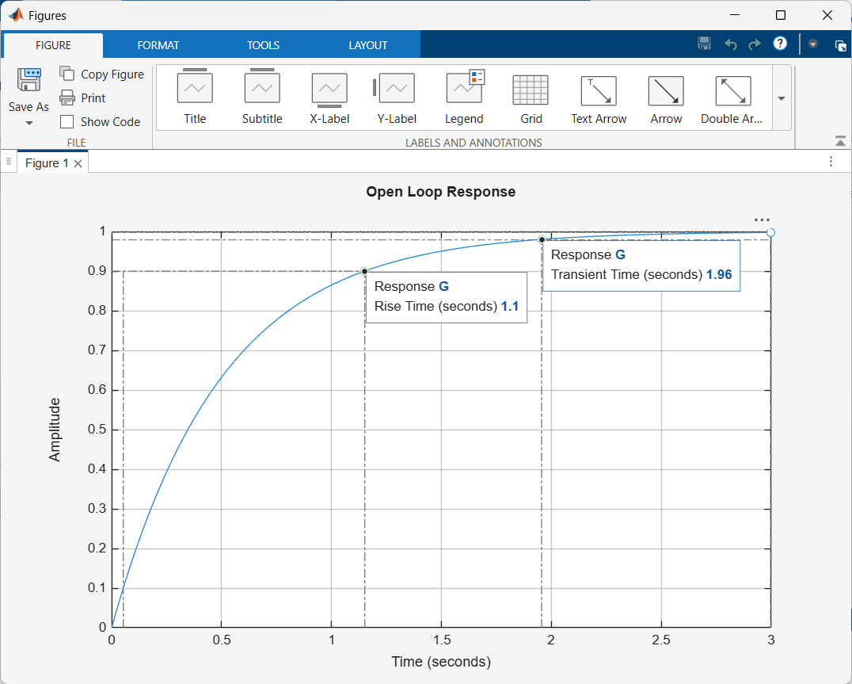
Settling time is nearly [4*T], as per the study notes we will be modelling our motor to be far more sluggish at [T=10]
Constructed a Bode Plot to verify open loop gain and phase margins
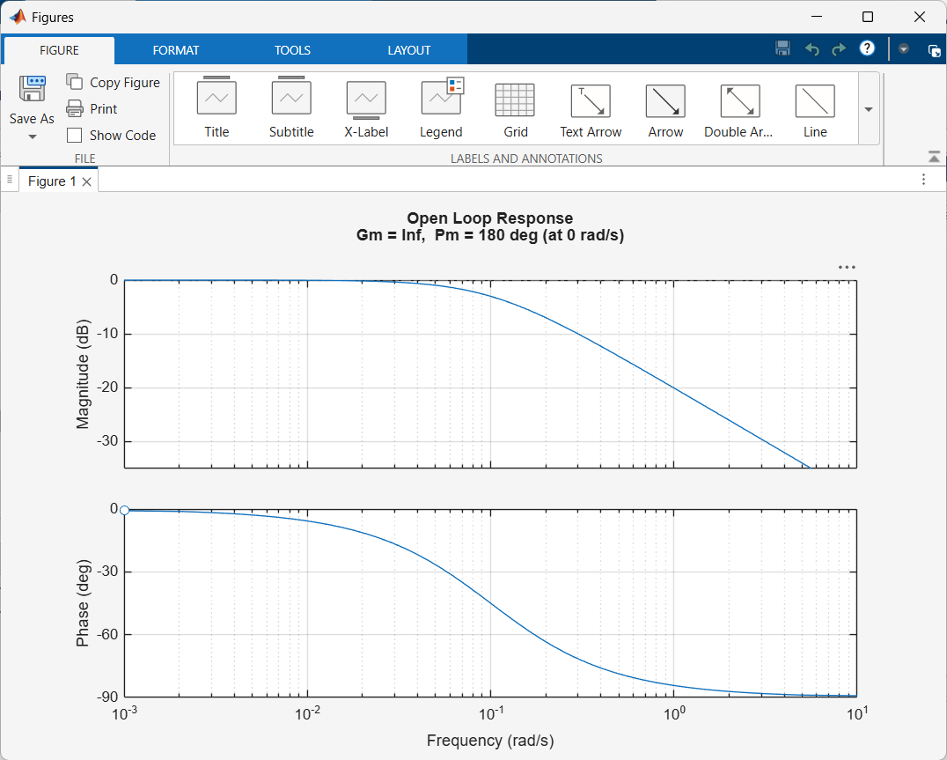
As per study notes, K must be calculated with [Steady State Speed (at 837)/100] – gives frequency increase per step (motor functions with center at 737)
Obtained steady state frequency (approximated by averaging) as [1.3420 Hz] and calculated [K = 0.013420] from the data saved in [motor/encoder_samples.dat] on [MyRig5] from a previous test run that happened to be running the motor at (837)
As per study notes, [Kp/Ki] must be equal to [T] to cancel out the slow-moving pole, thereby increasing stability – this takes a slight modification when the SIMC tuning rule is applied
Found [T = 0.083 s] (approx) from the same set of data, measuring from the last known 0 Hz measurement to the timestamp at which [freq >= 63%(1.3420 Hz)]
Found [Tdead = 0.0078 s] (dead time – delay between a serial input and the corresponding immediate change in the output) by measuring the difference between the timestamps of the serial input via the terminal and the first edge occurrence via gpiomon – this is when all the processes are to be running on [MyRig5]
Using the SIMC PID tuning rule on the modified expression [G = e^(-0.0078s)/((0.083*s) + 1)] under standard conditions ([Kp = Kc], [Ki = Kc/Ti], [Tc (tuning parameter) = Tdead], [Ti = min(T,(4*(Tc + Tdead))]), giving us the following results:
[Kp = Kc = T/(K*(Tc + Tdead))] [Kp = 5.32]
[Ti = min(0.083,0.0624)] [Ti = 0.0624]
[Ki = Kc/Ti] [Ki = 85.26]
The iSIMC PID tuning rule adds [Kd], provided the [Tdead] is relatively large wrt [T] for [Tdead/T < 5]; however, in our case [Tdead/T = 10.641], which is well beyond the domain wherein [Td = Tdead/3] can be considered to calculate [Kd = Kc*Td] – therefore, [Kd = 0] can be safely considered for this iteration of the PID control system
[PID = Kp + (Ki/s) + (Kd*s)] [PID = 5.32 + (85.26/s)]
When gain is taken as [K = 0.013420], we get [PID_K = (1/0.013420)*(PID)]
Constructed a Bode Plot for the closed loop system [L = G*C]
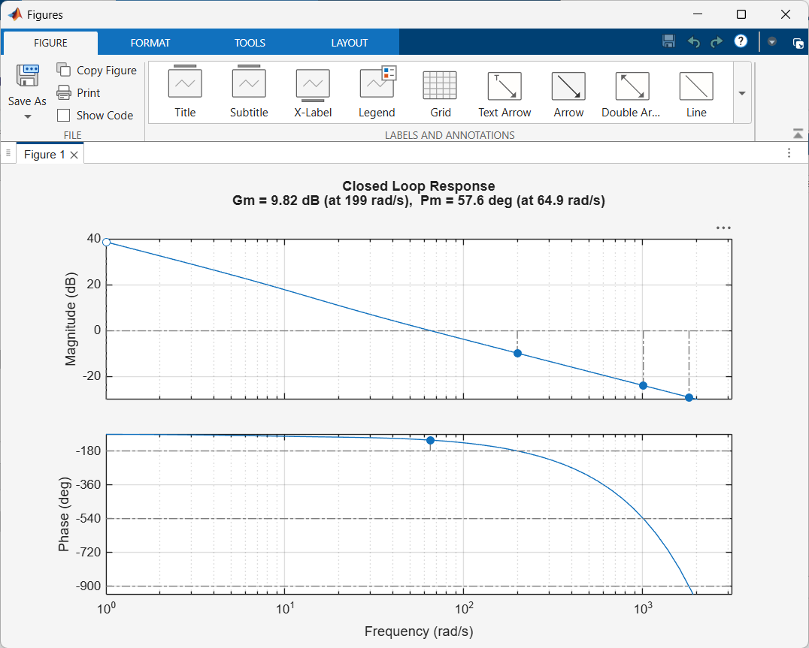
Obtained [GM = 9.82dB] At (-180 deg), the loop gain could increase by 9.82dB before reaching unity gain
Obtained [PM = 57.6 deg] Substantial tolerance to additional lag before the instability boundary occurs at unity gain
Ideally (as per study notes), [CF_ideal (in rad/s)= 0.5/Tdead]
So, [PM_ideal = 90 – (CF (in deg/s)*Tdead)] [PM_ideal = 90 – 28.648] [PM_ideal = 61.352 deg]; allowing the loop to tolerate [2*Td] before oscillating – our calculated PM is considerably close to the ideal case scenario and within the (30 deg – 60 deg) BW-Stability trade-off commonly cited by MatLab
Modified the [motor/controller.c] program on [MyRig5] with the calculated parameters
Serial output functionality needs to be built into the [motor/controller.c] program on [MyRig5] in order to automatically send serial control signals to the motor

